Thinking Together in Time:

A Cognitive Modeling Approach to Musical Synchrony in Jazz Ensembles

Marc Barcelos (202302260)

Cognitive Science MSc.

School of Communication and Culture

Aarhus University

Masters’s Thesis

Supervisor: Peter Keller

June 2nd, 2025

Character Count: 149945 (62.5 Standard Pages)

All code for the exam can be found in this GitHub repository:

<https://github.com/marcbarc19/Thesis_MarcBarcelos_2.6.25/tree/main>

Table of Contents

Summary 1

1. Introduction 2

1.1 Current Understandings and Approaches 3

1.2 Expanding Understandings to Group Settings 5

1.3 Modeling Cognitive Processes in Group Music Making 7

2. Methodology and Materials 11

2.1 Jazz Trio Behavioral Data Collection 11

2.2 Data Preprocessing 13

2.2 ADAM Model Fitting and Behavioral Metrics 14

2.3 Statistical Analyses 16

3. Results and Insights 17

3.1 ADAM Model Fit 17

3.2 Group Level Synchrony 18

3.3 Pair-Based Synchrony 24

3.4 Interpreting Collective Findings 33

4. Discussion 34

4.1 Interpretation of ADAM Model Results in Jazz Trios 34

4.2 Connections to Prior ADAM and Synchronization Research 36

4.3 Implications for Naturalistic Jazz Trio Performance 38

4.4 Broader Implications for Group Music Making 39

4.5 Limitations and Future Directions 40

5. Conclusion 42

References 44

Appendix 52

# Summary

Group music making requires individuals to flexibly coordinate their actions in real time. This temporal alignment relies on underlying cognitive mechanisms that allow performers to adapt to variability, anticipate future events, and dynamically shift attention between themselves and others. While these processes have been studied extensively in controlled dyadic settings, their interplay in naturalistic group performance remains underexplored. This study aimed to investigate how adaptation, anticipation, and attention control jointly support synchronization in jazz trios – composed of piano, bass, and drums – using the ADaptation and Anticipation Model (ADAM) to analyze behavioral data from real-world recordings. The ADAM provides a computational framework that estimates key parameters reflecting adaptation (phase and period correction), anticipation (temporal prediction), and joint sensorimotor integration (anticipatory correction), alongside inherent variability (timekeeper and motor noise). In this study, both an adaptation-only and joint version of the ADAM, including adaptation and anticipation parameters, were applied to each unique musician pair within a curated dataset of professional jazz trio performances. These parameters were then used to predict group-level and pairwise asynchrony via linear mixed effects models, with tempo, musical role, and rhythmic complexity included to examine how contextual demands shape coordination.

Results showed that both adaptive and anticipatory mechanisms contribute to group timing, with no single strategy proving superior. Instead, adaptation and anticipation emerged as interdependent strategies, flexibly recruited based on the rhythmic and structural demands of the performance. Musicians appeared to dynamically tune their timing strategies – not only responding to past deviations but actively forecasting upcoming events – especially under challenging conditions such as fast tempi or complex rhythmic passages. Attention control played a central role in this process, enabling musicians to switch between internal and external cues and selectively prioritize relevant partners or musical landmarks depending on moment-to-moment demands. Rather than relying on fixed correction tendencies, performers displayed a repertoire of timing strategies that could be reweighted as needed. These shifts reflect an ongoing integration of internal models of timing, predictions about partners’ behavior, and responsiveness to joint error signals. While individual roles within the ensemble influenced coordination (e.g., bassists and drummers anchoring timing more consistently than pianists), the core mechanisms underpinning synchrony were largely shared across performers, pointing to common internalized principles of joint musical action.

At a broader level, this study offers a new perspective on group synchrony as an emergent property of dynamic, multi-person coordination. By applying the ADAM to naturalistic jazz recordings, it bridges laboratory models of timing with the real-world complexity of improvisational group performance. The findings suggest that musical synchrony arises not from rigid behavioral rules but from a fluid negotiation between adaptation, anticipation, and attentional control, shaped by both individual intent and shared musical goals. This underscores the utility of computational cognitive models in unpacking how human minds connect in time, revealing that to perform music together is to engage in an ongoing act of mutual prediction, correction, and understanding. Group music making thus provides a window into the cognitive architecture of social coordination and the distributed intelligence that allows human groups to act as cohesive, expressive groups.

# 1. Introduction

Throughout the course of human history, group music making has served as a means for individuals to join together and collectively combine to express rhythmic, harmonic, and cultural stories that reflect shared values, beliefs, and social bonds (Leongómez et al., 2022; Savage et al., 2021a; Savage et al., 2021b). Though it is easy to identify examples that portray the importance of group music making across mediums such as the use of song in religion, the presence of music in collective celebrations, and the implementation of music to convey emotion in media, there are still large gaps in the current understanding of how underlying cognitive mechanisms contribute to this coordination amongst individuals and facilitate these pervasive phenomena (Greenberg et al., 2021; MacDonald, 2021; Stupacher et al., 2022).

Broadly, the form of interpersonal coordination that lies at the heart of group music making is known as social motor synchronization – a process that enables individuals to align their movements in time with others to achieve a shared goal or interaction (Grahn et al., 2021; Schmidt et al., 2011). Social motor synchronization not only underpins musical interaction but also informs a wide range of intentional and spontaneous joint actions. Social motor synchronization occurs spontaneously, for example, when applauding a performance as an audience member (Néda et al., 2000), walking in stride with another individual (Hajnal & Durgin, 2023), or unintentionally aligning breaths and blinks with an individual sitting across the table (Koul et al., 2023). This synchronization also plays a deliberate role in contexts such as playing sports, turn-taking behaviors such as conversation, improvised dance duets, and, namely in this context, music ensemble performances (Hadley et al., 2015; Keller et al., 2014; Kimmel, 2021; Vesper et al., 2013; Zamm et al., 2018; Zamm et al., 2023; Zamm et al., 2021). Because social motor synchronization shapes interactions from simple spontaneous gestures to complex effortful teamwork, understanding it on a mechanistic level is critical for linking the high-level cultural phenomena of group music making to the sensorimotor mechanisms that inform such shared experiences.

To approach this phenomenon scientifically, a cognitive modeling framework is adopted for the purpose of this study. This framework is based on the assumption that complex behaviors like group synchronization during music making can be explained at multiple levels of analysis, from observable behavioral interaction patterns to underlying psychological mechanisms that influence these actions (Anderson, 2013; Keller, 2023; Marr & Poggio, 1976). These mechanisms, while not directly accessible through observation alone, can be inferred using computational models that relate behavior to latent cognitive processes by operationalizing key sources of timing variability (Heathcote et al., 2015; Wilson & Collins, 2019).

The aim of this thesis is to better understand how musicians stay in sync during group performance, particularly in naturalistic jazz trios where timing is flexible, roles shift, and coordination is often unspoken. While previous research has explored how individuals adjust their timing in simpler, controlled settings, much less is known about how these processes unfold in more complex and realistic musical environments. This project applies a computational framework – the ADaptation and Anticipation Model (ADAM) – to explore how different cognitive strategies help musicians align with one another in time (Van Der Steen & Keller, 2013). The main question guiding this thesis is: to what extent can the ADAM and its underlying parameters explain and predict how musicians coordinate in real-world ensemble settings? To answer this question, the paper first outlines relevant theoretical and computational perspectives before detailing the modeling approach and statistical analyses, and finally presents the results alongside their broader implications. The results and discussion are organized in a deductive manner, by assessing overall ADAM fit, identifying predictors of synchrony at the group level, and unpacking interaction patterns between individual performers within the context of the group. By analyzing behavioral data from actual jazz recordings, the goal is to shed light on the mechanisms behind successful group music making and provide insight into the broader cognitive dynamics of collective performance.

## 1.1 Current Understandings and Approaches

To qualify the cognitive underpinnings that allow for group music making, much research has turned to computational modeling to tease apart how these cognitive processes contribute to the sensorimotor synchronization – the alignment of motor actions to a predictable external rhythm – required for this form of interpersonal coordination (Dumas et al., 2014; P. Keller, 2014). Group music performance provides a simultaneously naturalistic and highly structured context in which to investigate how multiple individuals coordinate their actions in real time to achieve a shared artistic goal (D’Ausilio et al., 2015; Heggli et al., 2019; Van Der Steen & Keller, 2013). A key characteristic of group music performance that lends itself to the application of computational modeling is the highly precise nature of coordination, with skilled musicians only deviating ~30-50 milliseconds on average in the timings between performers (P. E. Keller, 2014; Rasch, 1988). Given the continuous temporal demands and dependencies that occur between musicians, successful synchronization relies on a range of interrelated, dynamic sensorimotor processes deriving from a musician’s internal timekeeper – a neural mechanism that generates and maintains regular temporal intervals to support precise rhythmic coordination (Repp, 2005). These include the ability to adapt timing flexibly to external variability, predictively plan for future events, and maintain attentional control over multiple streams of information (Keller, 2001; Keller, 2012; Repp & Keller, 2004). A growing body of research has, as a result, aimed to identify and characterize core mechanisms that contribute to effective joint musical action, focusing on three major processes – adaptation, anticipation, and attention control.

### *1.1.1 Adaptation*

During live performance, musicians continuously fine-tune the timing of their actions to stay in sync with musical partners to combat both minor timing fluctuations, such as random, naturally occurring timing perturbations or intentional expressive fluctuations in tempo, as well as more substantial tempo shifts or large rhythmic errors. This temporal adaptation relies upon two interrelated error-correction mechanisms that keep each performer’s internal timekeeper tightly coupled with those of their partners (Large & Grondin, 2008; Repp & Keller, 2004, 2008; Vorberg & Wing, 1996). The first mechanism, phase correction, operates automatically by subtly shifting the alignment of one player’s sequence of timing pulses to align with the pulses generated by another, all without conscious intervention. Conversely, period correction is a deliberate adjustment of the individual’s internal timekeeper, utilized when a musician notices and actively compensates for tempo changes introduced by other performers. Together, these processes allow ensemble members to adjust for both small-scale variability and larger tempo alterations, preserving the group’s collective rhythm while remaining flexible to meaningful changes.

### *1.1.2 Anticipation*

In conjunction with this, musicians also depend upon anticipatory cognitive processes to synchronize their own actions with those of other performers (Keller, 2012). Research on temporal anticipation, the capacity to predict when temporal events will occur, indicates that these predictions can arise from two distinct, but complementary, paths. The first pathway consists of automatic mimicry and expectancy that arises without conscious effort. More specifically, this refers to a musician’s ability to unconsciously internalize perceptual cues such as accent patterns (a musician’s patterned emphasis on a given beat, often on upbeats or downbeats) or phrasing cues (musical signals that performers use to delineate and shape musical “sentences” or phrases) which reflect statistical regularities learned through prior experiences and trigger ingrained neural responses that align an individual’s internal timekeeper with the group’s shared tempo (Konvalinka et al., 2010; Schwartze et al., 2012; Vuust & Witek, 2014). The second pathway involves deliberate mental projections of tempo changes, known as effortful temporal extrapolation. In this case, musicians use working memory to hold recent timing patterns and actively anticipate accelerations or decelerations in order to adjust their own onset times accordingly, utilized for example in planned accelerations and decelerations in a piece of music (Van Der Steen & Keller, 2013; Vuust & Witek, 2014). Certainly, proficiency in this effortful route varies across individuals and correlates with higher-order cognitive skills: selective attention helps performers focus on relevant musical cues amid complex textures (Pecenka et al., 2013), robust working memory supports the maintenance and manipulation of temporal information (Colley et al., 2018), higher temporal prediction abilities lead to better synchronization during interpersonal coordination tasks (Pecenka & Keller, 2011), and strong auditory imagery allows one to “hear” upcoming sounds internally before they occur (Pecenka & Keller, 2009a, 2009b). That being said, both routes are relied upon to a large extent in the context of group music performance in order for musicians to not only react, but to plan their actions to better synchronize with their peers.

### *1.1.3 Attention Control*

As displayed above, both adaptory and anticipatory processes rely on processing both one’s own temporal information as well as potential partners’ information. As such, musicians must split their attention between their own playing – prioritized to maintain personal accuracy – and their partners’ output, all while remaining cognizant of the collective sound. This process, prioritized integrative attending, requires both self­­­­–other segregation, distinguishing one’s own auditory stream from others’, and self­­­­–other integration, combining those streams into a coherent whole, in order to effectively divide attention (Keller, 2001; Keller & Burnham, 2005). Segregation supports the musician’s individuality, allowing them to retain control and continuously enhance their own part (De Jaegher & Di Paolo, 2007; Kahl & Kopp, 2018; Pacherie, 2012), while integration makes it possible to understand how individual actions shape joint outcomes in order to ensure that the performers meet shared musical goals (Loehr et al., 2013; Sebanz et al., 2006). By dynamically shifting the balance between these two modes of listening, performers can address intrapersonal disturbances without placing the group’s interpersonal aims at risk (Heggli et al., 2019; Keller et al., 2016; MacRitchie et al., 2018).

To operationalize and measure these three cognitive processes of sensorimotor synchronization during group music making, several computational approaches have been developed to quantify adaptation, anticipation, and attentional control during performance, culminating in the ADaptation and Anticipation Model (ADAM) (Van Der Steen & Keller, 2013). The ADAM is a cognitive timing model that estimates how individuals adjust their actions in response to past errors – adaptation – and predicted future events – anticipation. The specific mechanisms and parameters used to achieve this will be described in detail later in the thesis. The following section builds on this foundation by examining how adaptation, anticipation, and attention extend specifically to group performance contexts, where coordination demands become more complex due to multiple interpersonal relationships.

## 1.2 Expanding Understandings to Group Settings

### *1.2.1 Adaptation*

When in a group, individuals have been found to continuously correct timing errors relative to shared cues or neighbors. For example, Honisch et al. (2016) found that, in groups of six divided up in different contexts, those with a single partner worked to minimize the variance of their asynchrony with their partner, whereas the person integrating two partners’ sensorimotor cues worked instead to minimize their own motor variance. This displays group members’ flexibly in switching between various adaptation error-correction strategies depending on available cues. Similarly, Thomson et al. (2018) studied audience clapping and observed that groups of all sizes accelerate their tempo, revealing through modeling that this occurs because individuals correct more strongly to claps preceding their own than those after, driving a collective acceleration, further exemplifying dynamic adaptation strategies based on group size. Supporting these findings, Wing et al. (2014) used an optimal feedback control model to show that string quartet musicians adjust their timing by balancing corrections to their own errors with responsiveness to their partners. This suggests that in group settings, adaptation strategies are carefully calibrated to optimize both individual accuracy and overall ensemble synchrony.

In controlled tapping tasks, these adaptive processes have been found to aid group synchrony. In a “multi-person adaptive metronome” study with four participants, researchers concluded that moderate adaptivity (25–50% phase correction) significantly improved synchronization with a fixed tempo (Fink et al., 2022). A high level of adaptivity (70–100%) still helped participants so long as they heard each other, though synchrony collapsed without. Taken together, groups seem to benefit from error-based corrections, particularly when sensory cues helped to link coordinating individuals together. Large ensembles are also aided by these adaptive processes over time. By recorded a 16‐piece improvising orchestra, researchers found that, despite no conductor or shared plan, musicians’ actions and intentions became interdependent and mutually adaptive (Goupil et al., 2020). This learning reflects adaptation at the group level, as performers adjust their timing strategies to optimize global coherence. These findings imply that the application of the ADAM at the group level may be able to find dynamic relationships in adaptivity in relation to particular group members and other group members they may or may not be attending to.

### *1.2.2 Anticipation*

Alongside adaptive corrections, predictive timing mechanisms seem to also be vital in larger groups, as they allow individuals to anticipate upcoming events rather than merely react to past errors. In a study of conductor‐led orchestras, experienced musicians tapping to silent videos of a conductor’s gestures were found to have an activated superior frontal network, indicating they were predicting the conductor’s next motion and suggesting that the use of anticipation in a group context likely occurs (Ono et al., 2015). The efficacy of anticipation as a synchronization tool may extend to larger groups as well, as a model of performance data from 16 violinists whose coupling could be controlled in real time found that violinists achieved group synchrony by dynamically adjusting their own tempo to others or selectively ignoring others. Effectively, the musicians excluded conflicting cues from forward predictions, allowing the ensemble to better synchronize (Shahal et al., 2020). This further suggests that, in a group context, musicians implicitly used selective predictive mechanisms to achieve sensorimotor synchronization. Findings from human–machine trios extend this finding to mixed ensembles. In a study by Van Kerrebroeck et al. (2025) of trios that included two humans and one virtual partner, results showed that the inclusion of a virtual partner driven by predictive oscillator models significantly improved synchronization stability and perceived cohesion compared to all‐human trios, adding to the potential efficacy of anticipation as a synchronization tool in group music making. However, it is important to note that this study primarily involved coupling dynamics, which are more closely aligned with adaptation rather than anticipation. This distinction points to a current gap in the literature, as few models account for the full range of anticipatory processes that arise during group music-making. Together, these studies underscore that anticipation is highly relevant to explore in the case of multi-person synchronization, though few cognitive models of forward prediction have been applied to groups of three or more, let alone in conjunction with adaptation and attention control.

### *1.2.3 Attention Control*

Maintaining synchronization in groups of three or more also seems to hinges on attention control to the most informative sensory cues. A study of folk‐dance circles including 13 performers demonstrated that dancers dynamically shifted their focus among sensorimotor channels, based on the form of movement and the channels effectiveness in supporting prediction processes (Chauvigné et al., 2019). Repeated practice over the course of the study further improved cross‐modal integration, highlighting how attention control can dynamically weight multiple sensorimotor streams during group sensorimotor tasks. In the controlled tapping task discussed above in relation to adaptation, the study’s finding that high metronome adaptivity (70–100%) fails without peer auditory feedback suggests a deficit that comes with the inability to integrate shared cues, possibly pointing to the necessity of a dynamic connection between self and other cues in a group setting (Fink et al., 2022). Similarly, in a mixed human–virtual setup with up to eight agents, Alderisio et al. (2016) showed that embedding simple adaptive rules into some agents only improved group synchrony when all participants could perceive one another’s actions, further highlighting the interplay between adaptation, anticipation, and attentional coupling. In support of this, work on neural self–other integration and segregation has shown that attention to internal versus external timing cues varies depending on task goals and knowledge of other musicians’ parts (Christensen et al., 2023; Novembre et al., 2016). Recent work by Schwarz et al. (2025) adds further evidence from free improvisation contexts, showing that covert variations in a musician’s loudness can guide the attention of fellow performers and shape their interactions, emphasizing the role of dynamic cues in attentional control. The state of the literature currently points to a likely reliance on active attention control in multi‐person sensorimotor synchronization, as performers must continuously direct attention to the most reliable sensory inputs to both anticipate and correct timing deviations.

### *1.2.4 Gaps and Future Directions*

Existing models, as touched upon above, have been utilized to demonstrated that group synchronization can emerge from local interactions between group partners, yet no single cognitive framework currently integrating adaptation, anticipation, and attentional control for ensembles of three or more performers has been applied, namely in the context of group music making. Most experimental work, particularly in relation to the application of the ADAM, still focus entirely on pairs, with naturalistic group settings left underexplored. This gap also extends to how synchrony is measured. Pairwise asynchrony values that capture asynchrony between a target musician and a performer they are coordinating with are used regularly to explore coordination in performer dyads, whereas group asynchrony values, which captures a group’s overall temporal coherence, are rarely utilized to explore naturalistic group performance. Because these metrics can reveal distinct yet complementary aspects of group coordination – namely local versus global dynamics – both levels are examined in the present analysis to better understand how synchrony emerges within and across musician pairs in a group context. At the group-level, research has thus far treated adaptation, anticipation, and attention separately in this context or otherwise not made a clear distinction between them. The interactions among these processes in groups settings is not well characterized. For instance, does the complexity of a given musician’s performance or musical role (i.e. a rhythmic leader like drums) modulate the likelihood of utilizing adaptation and anticipation techniques and focusing attention internally? Does the tempo of a given performance modulate the mechanisms used to remained synchronized? Current literature suggests that this may well be true; however, no current study effectively explores the interactions of the process at both the group and individual level (Keller & Burnham, 2005; Sabharwal et al., 2024). As such, the literature calls for paradigms that focus upon ecologically valid group tasks that vary sensory coupling and cognitive demands, as well as the mechanisms utilized by individuals within these tasks across contexts.

## 1.3 Modeling Cognitive Processes in Group Music Making

Given these research gaps and the current understanding of adaptation, anticipation, and attention control in group contexts, extending the ADAM to group music making tasks may lead to informative findings as it related to multi-person sensorimotor synchronization. By treating each pair of musicians within a larger ensemble as a dyad, the ADAM framework can be applied across all unique pairings to map out the fine-grained synchronization dynamics that underlie group synchronization. For any two players, ADAM’s adaptation parameters can quantify how each adapts to timing errors with that specific partner, while its anticipation parameter captures how strongly each predicts that partner’s next event. By estimating these parameters for every pair in the group, a group synchronization profile is revealed, highlighting which relationships rely more on reactive correction versus predictive alignment as well as when a musician prioritizes cues from one partner over another – potentially modulated by a musician’s musical role in a piece, the complexity of a musician’s playing, or the tempo of the overall piece. Aggregating these dyadic profiles using the ADAM will effectively produce a networked picture of group synchronization, teasing apart individual contributions to the sensorimotor synchronization in group music making and developing a quantitative understanding of how adaptation, anticipation, and attention control combine to generate coherent group performance. Emphasizing the move toward ecologically valid group music making contexts, current work suggests that adaptation, anticipation, and attention control are dynamically adjusted according to task demands – for example, adaptation strategies shift with partner number and cue reliability, anticipatory timing strengthens when temporal structure or leadership cues are salient, and attentional focus pivots among sensorimotor channels as needed. To better understand how the ADAM can reveal the dynamic relationships between the cognitive mechanisms that inform group synchrony, its core modules and how they interact must be clearly defined.

### *1.3.1 The ADaptation and Anticipation Model*

The ADaptation and Anticipation Model (ADAM) is a linear event-based model that describes sensorimotor synchronization as a sequence of discrete events modulated by three interacting computational modules, each representing sensorimotor processes that inform action planning and prediction within the performer and their partner as well as a combined module that integrates the two (Mills et al., 2019; Van Der Steen & Keller, 2013). While the ADAM is grounded in dyadic interactions, its application to group music making involves extensions that account for multiple, concurrent coordination dynamic. As shown in Figure 1, each component in ADAM is parameterized independently, with all parameter values able to be estimated for individual performers by fitting the model to their discrete time-series data, often in the form of tapping or musical performance data such as note onsets (Harry et al., 2023; Mills et al., 2019; Van der Steen, Jacoby, et al., 2015; Van der Steen, Schwartze, et al., 2015).

Displayed below is ADAM’s three-module interconnected architecture in which each person’s movements generate sounds that cue their partner’s responses, creating a continuous feedback loop. Temporal alignment within this loop is achieved through the implementation of the three cognitive processes highlighted thus far: adaptation, which updates Musician A’s internal timekeeper to correct for any synchronization errors, anticipation, through which Musician B’s internal model predicts the musician’s next beat, and joint error correction via attentional control, which adjusts planned actions by comparing self-generated plans with other-based predictions. Variability is introduced through small errors in both musicians’ internal timekeepers as well as the inherent timing variations that occur with motor actions.

**Figure 1A**

***Diagram of the Adaptation and Anticipation Model***

*Note.* From “Tutorial and simulations with ADAM: an adaptation and anticipation model of sensorimotor synchronization,” by B. Harry and P. Keller, 2019, *Biological Cybernetics. 113*, (https://doi.org/10.1007/s00422-019-00798-6).

The adaptation module is updated by implementing the two forms of error correction mentioned prior: phase (α) and period (β) correction. It starts with a timekeeper interval (*Tn*) that represents Musician A’s current tempo estimate. When a tone or tap from Musician A (self) is misaligned from Musician B (other), an asynchrony value (asynn) is determined based on the temporal discrepancy between the two (Wolpert & Kawato, 1998). Using these values, the time until Musician A’s next note, otherwise known as the inter-tone interval​, is calculated as such;

*Tn + (α + β) × asynn*

and their internal timekeeper is updated using a similar equation provided here:

*Tn+1 = Tn + (β × asynn)*

Mirroring real life, phase correction produces a slight adjustment to account for variability without changing the musician’s underlying timekeeper, whereas period correction has a lasting change on the timekeeper. As a result, this creates a ‘self’ internal model wherein phase correction shifts the next response to counteract immediate timing error, while period correction gradually aligns the individual’s internal timekeeper with sustained tempo changes.

The anticipation module is updated by generating predictions for the other individuals next tap through the extrapolation of recent tempo patterns (Wolpert et al., 2003). ADAM treats Musician A’s last three or more intervals inter-tone intervals as data points and fits a linear regression. A best-fit line is used to identify the linear equation that minimizes the squared error relative to the inter-tone intervals, capturing a linear relationship between the successive intervals. Extrapolating from this equation one tone into the future yields the predicted interval and, therefore, the temporal prediction (*δ*) for the expected note onset of Musician B’s next tone. In other words, if the partner has been speeding up, the model predicts an even shorter inter-tone interval to the next, and, if slowing down, it predicts a longer one. This predictive process instantiates an ‘other’ forward model which uses ADAM’s internal representation of Musician B’s timing tendencies to forecast the next tap. In practice, ADAM can simplify this tracking by simply copying the most recent inter-tone interval instead of extrapolating via the best fit line. By adjusting how much the model extrapolates versus copies the last inter-tone interval, ADAM can blend predictive and preservative coordination. Namely, it will predict ahead to adapt to consistent tempo changes but can always rely on moment-to-moment tracking as needed (Konvalinka et al., 2010). The result is an anticipatory module that can produce either predictive or tracking note production depending on what the context calls for, mirroring the anticipatory pathways described earlier.

**Figure 1B**

***Relationship between ADAM Parameters, Stimuli (S), Responses (R), and Asynchronies (A)***

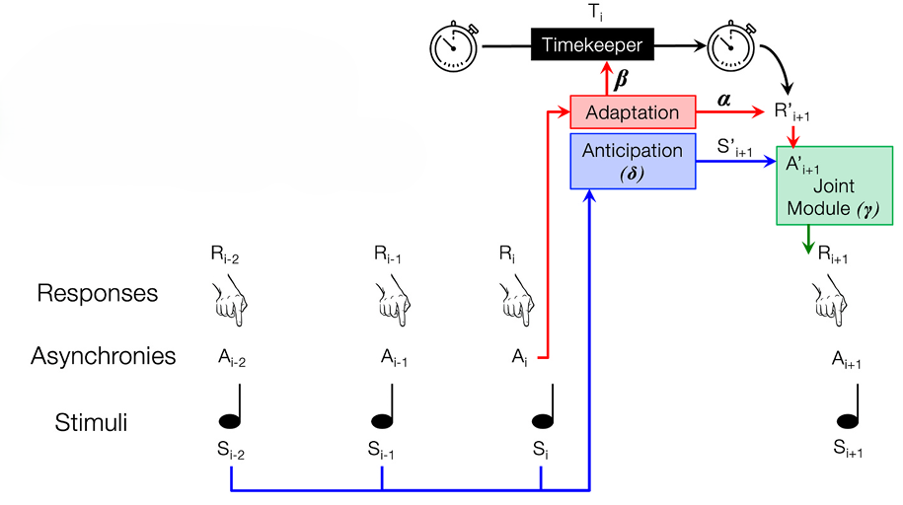

Phase Correction (α)

Period Correction (β)

Temporal Prediction (δ)

Anticipatory Correction (γ)

*Note.* From “Brain networks for temporal adaptation, anticipation, and sensory-motor integration in rhythmic human behavior,” by B. B. Harry, D. S. Margulies, M. Falkiewicz, & P. E. Keller, 2020, *Cerebral Cortex*, 30(10), 5661–5675, (https://doi.org/10.1093/cercor/bhaa129)

The final module, the joint module, resolves any potential discrepancies that lie between the values produced from both the adaptation and anticipation modules to avoid potential conflicts (Keller et al., 2016; Van Der Steen & Keller, 2013). As it stands, the adaptation module’s planned tone time is utilized in Musician A’s ‘self’ internal model to both determine their motor command for the current tap and to predict, in conjunction with their previous actions, when their next tone would occur if that command were executed. Independently, the anticipation module’s prediction serves as the ‘other’ model of Musician B’s next note onset. The two predicted times produced – self and other – are compared in the joint module. If the predicted asynchrony is below a low threshold, ADAM proceeds with the planned action derived from the adaptation module. However, if the predicted asynchrony exceeds the threshold, ADAM performs an *anticipatory error correction* by overriding this plan with default adjustment applied to the existing motor plan to reduce the mismatch. In summary, this means the joint module either selects the adaptation-based interval or the anticipation-based interval to minimize the predicted error. By doing so, the joint module proactively corrects by simulating, or “practicing”, the timing internally and adjusting any large prediction errors before a real note is produced. This mechanism ensures a musician’s motor output not only reacts to past errors via phase and period correction but also anticipates future errors by blending the two internal predictions dynamically. To improve the ecologically validity of the ADAM, the model also implements a widely recognized two-level framework for timing variability in rhythm production by including both timekeeper noise to reflect the variability in neural timing and motor noise to reflect the external variability of motor actions during action execution (Schulze et al., 2005; Semjen et al., 2000; Semjen et al., 1998; Vorberg & Schulze, 2002a, 2002b; Vorberg & Wing, 1996; Wing & Kristofferson, 1973a, 1973b).

With the adaptation, anticipation, and joint modules, the ADAM can be built simply or expanded using different combinations of the modules to pinpoint the contributions and importance of each. As has been standard in previous work (van der Steen, Jacoby, et al., 2015), the focus here will be to explore the distinctions that lie between two versions of the ADAM: the ‘adaptation-only’ and ‘full’ version (Harry et al., 2023; Van der Steen, Jacoby, et al., 2015). The adaptation-only version includes phase correction and period correction from the adaptation module in addition to both timekeeper and motor noise, while the full ‘joint’ version includes period correction from the adaptation module, temporal prediction from the anticipation module, and anticipatory error correction from the joint module, as well as timekeeper noise. According to Harry and Keller (2019), the adaptation-only is sufficient for steady tempo performances whereas the joint version accounts better for performance in tempo-changing scenarios, though it will be interesting to explore if this remains true in the context of group music making. To be able to explore this, both versions were limited to the same number of parameters – in this case, four – so that their fits could be compared directly.

### *1.3.2 Applications and Current Knowledge of ADAM*

Since its inception, the ADAM and its modules have been leveraged across various sensorimotor synchronization paradigms, yielding with it insights into which cognitive processes drive timing behavior with these contexts. Its modular framework has enabled researchers to model both individual and partner synchronization processes. In paradigms involving a human participant and a computer-simulated partner, where an individual synchronizes with a virtual partner that adapts in real time, ADAM’s parameter estimates for phase correction, period correction, and anticipatory prediction have been shown to predict synchronization accuracy (Harry et al., 2023), further supporting previous work exploring human-based sensorimotor synchronization in independent behavioral tasks and dyadic (pair- based) musical settings (Keller & Appel, 2010; Keller & Burnham, 2005; Keller et al., 2010; Repp & Keller, 2004). Moreover, computational simulations of ADAM have further tested the ADAM’s structure, with single-agent simulations – an ADAM-driven simulated agent adapting to an external tempo guide such as a metronome – show that only phase correction is necessary under steady tempi, whereas anticipation becomes essential in tempo-changing contexts (Harry & Keller, 2019). Within the same study, dual-agent simulations, in which two ADAM-driven agents interact – one following a consistent beat and the other a varying one – reveal that timing stability improves when only one agent engages in strong anticipatory correction, resembling leader–follower dynamics observed in human musical dyads. Taken together, current applications of ADAM have substantially advanced our mechanistic understanding of dyadic synchronizations, from computational simulations to fMRI‐informed parameter estimates, yet the mechanistic drivers of group music making with three or more musicians remains largely unexplored. This represents an valuable opportunity expand the current understanding of how sensorimotor coordination impacts social motor synchronization in naturalistic group music making contexts.

### *1.3.3 Project Objectives*

The ADAM provides a robust, quantitative framework for disentangling these mechanisms by fitting both adaptation-only and joint ADAM versions to each unique dyad within a group, generating a detailed synchronization profile that captures how musicians distribute reactive correction, forward prediction, and selective attention during real performance. For this particular study, jazz trios were selected for analysis as an ideal test paradigm. Their limited number of performers leads musicians to, at times, develop close interdependencies, their improvisational nature introduces natural variability and moments of self-facing focus, and their well-studied repertoire provides clear structural landmarks. Through the application of the ADAM model to naturalistic jazz trio performance, the three following research questions will be explored:

1. Which version of the ADAM performs the best at modelling the jazz trio performance behavioral data? Does this performance generalize across piece tempo, musical role (instrument), and part complexity?
2. At the group level, which ADAM parameters best predict group asynchrony for both model versions, and how are these predictions modulated by tempo and piece complexity? Furthermore, is tempo and piece complexity reflected in asymmetries in parameter estimates and do these conditions have an effect on interpersonal synchrony?
3. At the pair level, which ADAM parameters best predict pairwise synchrony across model versions, and how are these predictions modulated by tempo, musical role, and part complexity? Furthermore, is part complexity, musical role, and piece tempo reflected in asymmetries in parameter estimates and do these conditions have an effect on interpersonal synchrony?

# 2. Methodology and Materials

## 2.1 Jazz Trio Behavioral Data Collection

To explore the performance of the ADAM on naturalistic jazz trio performance, the Jazz Trio Database, created by Cheston et al. (2024), was utilized. The Jazz Trio Database is an open-source dataset of automatically transcribed jazz trio recordings intended to produce a large-scale pool of data for previously undocumented semi-improvised music. To accumulate the pieces for inclusion in the dataset, piano-bass-drums trios considered to be “popular” and “prolific” were selected and their discography’s were compiled, with any duplicates, non-piano-bass-drums trio, or incomplete recordings. From these initial 18,504 tracks, stringent inclusion criteria were applied: a tempo between 100 and 300 beats per minute (bpm), 3 or 4 quarter note beats per measure, the inclusion of an uninterrupted piano solo supported by bass and drum, a “swung eight” rhythmic-feel common to jazz, the use of only acoustic instruments played traditionally, and a related YouTube link. These criteria were selected to ensure that the dataset reflected musically and metrically consistent examples of mainstream jazz trio performance. In particular, parameters such as stable tempo, clear meter, uninterrupted solo sections, and swung rhythmic feel were essential to isolate naturalistic yet structurally analyzable segments of group synchronization. This reduced the pool of discography down to 1,294 pieces spanning 44.5 hours and 201 jazz trios. Metadata, including the group leader, tempo, and time signatures, were merged.

Once the final set of sources were selected, annotation began with source separation, where the ZFTurbo audio source separation model demixed each track into bass, drums, vocals, and other sources (Solovyev et al., 2023). A Butterworth bandpass filter was then utilized to extract piano frequencies (55–3520 Hz) from the other (Edwards et al., 2023). The resulting separated stems fed into a three‐stage data extraction pipeline. The first stage consisted of the use of the *CNNOnsetDetector* function in *madmom*, an audio signal detection library, to detect onsets for each separated part using each musicians’ audio spectrogram (Böck et al., 2016). *DBNDownBeatTracker* from the same package was then used to detect the beats dictating the tempo and measures – quarter notes and downbeats – via inferences made from the same spectrograms. Lastly, onsets extracted from the first stage were matched with beats extracted from the second stage to notate each notes placement in a measure in relation to the beats. Onsets occurring within one thirty‐second note before up to one sixteenth note after a beat were annotated as within that beat. The onset with the smallest temporal offset from the beat was matched. If no onset fell inside this window, that beat was considered to be left empty by the musician.

**Figure 2**

***Data Collection Pipeline***

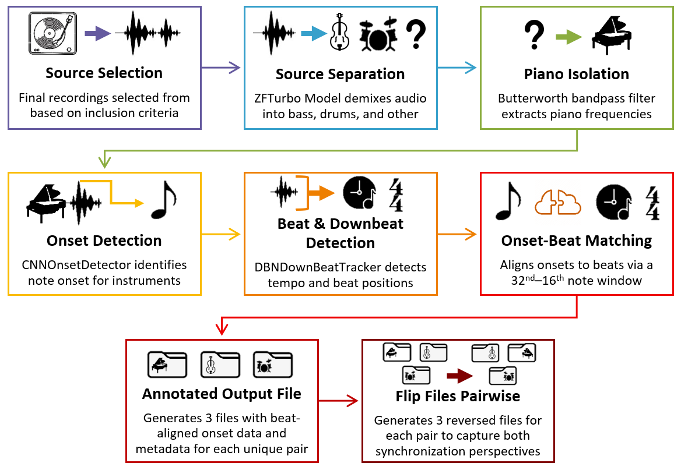

*Figure 2 provides a visual representation of each step of the data collection pipeline, starting with the selection of the original source all the way to the production of six files for further statistical analyses.*

This process resulted in a unique file for each piece in the dataset containing onset values for the piano, bass, and drums, the beats they were matched with, and the overall meter of the piece as well as the associated metadata. For onset values and beat values, a single unit signified one beat of the current piece, meaning each unit signified a different length of time given the tempo of the piece. Though the model was validated as an effective automatic annotation tool, this process holds with it certain limitations that are important to consider when applying this data to the ADAM. Automatic source separation can occasionally lead to bleeding between instruments, namely due to piano audio experiencing leakage from the “other” channel even after filtering, though the effectiveness of the library suggests this won’t significantly or systematically inhibit the data. Moreover, the *CNNOnsetDetector* and *DBNDownBeatTracker*, while state-of-the-art, still occasionally miss events or produce false positives when the audio is particularly noisy. The onset-beat matching window also comes with limitations, mainly that onset measures lose definition in regard to their measurement at the millisecond level due to this form of standardization. Presumably, important relationships in the data may be lost to ambiguity due to the scale of these measurements, though more precise automated measurements are unlikely with the current state-of-the art. Nonetheless, given the importance of obtaining large-scale, time-aligned data for testing and refining ADAM in real‐world group music making contexts, this automated annotation pipeline remains the most reliable option to achieve this goal.

## 2.2 Data Preprocessing

To prepare the data for the application of the model, the onset values for all the available files were split for each unique combination of musicians – piano and bass onsets, piano and drum onsets, and bass and drum onsets. For the purpose of clarity, the onset values from Musician A (in the case of piano and bass synchronization, the pianist) is referred to as tones and the onset values from Musician B (in this case, the bassist) as responses. For each of the three subfiles derived from the original data, five variables – inter-tone intervals (ITI), tone onset time, inter-response intervals (IRI), response onset time, and tone-response asynchronies – were extracted and restructured for each trial. Inter-tone intervals (ITI) and inter-response intervals (IRI) were computed by subtracting the tone or response onset value times of the previous note from the times of the current note. Additionally, tone-response asynchronies, referred to simply as asynchronies throughout the duration of the study, were determined by finding the difference between tone and response time for each beat. To concisely include all the relevant information for each note, the first value for both tone and response were excluded from the restructured files, as two values for tap and tone time are needed to extrapolate the remaining variables, thus placing these variables one row removed from their related onset values. The remaining values were shifted upwards to correctly align with their related remaining variables. This resulted in a corresponding file for unique dyads within an original piece containing all five variables of interest correctly aligned for the ADAM model, totaling 3882 unique files.

Upon completion of splitting and preparing the original files, the subfiles underwent further filtering, displayed in figure 3, to ensure the ADAM model could effectively model the data. The first stage of this filter process focused on outliers in file length, or number of rows, with files in the bottom and top tenth percentile being excluded from the analysis, leaving 3102 files. To address the potential modeling and statistical concerns that come with extensive missing values, the proportion of missing values in a given row as compared to the total number of rows in a file were used to exclude files. Those with a missing value proportion above 25% were further excluded, reducing the number of files to 792, representing pieces from 101 trios. To further reduce the impact of missing values on the performance of the model, the remaining files were scanned for sections where missing values were present in six or more rows. If and when these sections were identified, the rows were removed and the data was concatenated. Though slight perturbations in the results occurred due to the ITI and IRI values following these sections no longer corresponded to the previous row, it was found that these exclusions caused no significant differences to the analyses and allowed for more files to be explored, justifying its usage. Lastly, the files were then duplicated and inverted so that the musician considered to be Musician A in the current state of the file was now considered Musician B and vice-versa, totaling in two mirrored files for each unique pair, six total file versions from each original piece, and 1584 for further analysis.

**Figure 3**

***Filtering of Unique Behavioral Data Files***

|  |  |
| --- | --- |
| A. Dataset Length |  |
|  |  |
| B. Missing Value Proportion |  |
|  |  |

*Figure 3 displays histograms of the data before and after each filtering step. Panel A displays the frequency distribution of file lengths before and after the exclusion of the top and bottom ten percent of the data. Panel B displays the frequency distribution of missing value proportions, or ratio of rows with a missing value to total rows in a file, before and after the exclusion of files with a proportion above 25%.*

## 2.2 ADAM Model Fitting and Behavioral Metrics

From each piece, all six corresponding files were then inputted into a MATLAB script responsible for the application of the ADAM model to the restructured data (*MATLAB*, 2020). This script included four key steps for fitting the model, the first of which was the setting of the parameters the data had to meet for the application of the ADAM model. These parameters included the permitted number of total (250, determined to be the maximum value of missing values in a file within the dataset), and consecutive (1, to limit issues caused by interpolation) missing events for taps and outlier asynchronies, the maximum value for asynchronies (3 beats), the number of iterations for the ADAM model fitting (20), the K-ratio for the model (1), and the bounds for the model parameters (-1 to 2). The script then checked that each file met the aforementioned exclusion criteria for missing values, removing those that did not. Linear interpolation was utilized to replace any remaining missing values while remaining conservative in the effects of this adjustment on the behavioral data (Tremblay et al., 2006). Descriptive statistics were then computed for inter-tone intervals, inter-response intervals, and both signed and absolute asynchronies. Both the adaptation-only and joint version of the ADAM model were fit using the interpolated data for ITI, IRI, and asynchronies, returning parameter and model performance values for both models. Log-likelihood scores were then calculated for both versions as measures of the model fit and performance.

**Table 1**

***Description and Interpretation of Statistical Variables***



*Table 1 displays all of the variables used for the various statistical analyses undergone in this study, as well as a description of what the measure is and the way in which each metric should be interpreted when referring to their original, untransformed values.*

A CSV file including the values highlighted in the previous paragraph was saved and accessed within RStudio to compile the final two measures necessary for statistical analysis (RStudio Team, 2020). To fully explore the research questions, complexity scores were operationalized as the Shannon entropy of all the inter-tone intervals in a performance (Milne et al., 2023). In this case, a higher Shannon entropy signifies greater variability and complexity in timing and a lower entropy indicates more regular, predictable intervals. At the group level, complexity was measured using a weighted sum of the complexity scores for each musician within a given piece, with musicians with more notes performed being weighted more strongly. Lastly, group asynchrony was measured by calculating the root mean square of asynchrony standard deviations for all three musicians present within a given piece (Clayton et al., 2020; Rasch, 1988). This approach was used because the root mean square helps to summarize the overall asynchrony between the musicians in a way that accounts for variations in timing, providing a global measure of the quality of synchronization at the group level. Upon completion, the dataset included all relevant information to answer the aforementioned research questions – including model parameters, performance scores, descriptive and complexity metrics, group asynchrony values, quality assurance measures like number of missing events, and general performance characteristics such as tempo. All of the relevant variables within the dataset implemented in the statistical analyses are described in table 1.

## 2.3 Statistical Analyses

Using this completed dataset, multiple different statistical analyses were implemented to address the main aims of the article, namely determining which ADAM model best fit the data, identifying the model parameters most predictive of group and pairwise synchrony, and assessing the extent to which musical role, part complexity, and piece tempo were reflected in parameter asymmetries and their impact on asynchrony. For all of the variables included in the statistical analyses below, normality assessments were performed using the R package bestNormalize, with the best performing normalization method being implemented if they provided sizable normality improvements (Peterson, 2021). With the adaptation-only model version parameters, phase correction, period correction, timekeeper noise, and motor noise were all normalized using ordered quantile normalization (ON), helping to meet statistical assumptions without relying on parametric transformations (Peterson & Cavanaugh, 2020). While effective and robust to outliers, this method reduces data, meaning any inferences must refer back to the original data scale. For the joint model version parameters, period correction, temporal prediction, auditory correction, and timekeeper noise values were also normalized using ON normalization (Appendix, A.3). Furthermore, log-likelihood (LLE) values and asynchrony values were also normalized in the same manner.

To explore the first research question which aims to investigate which version of the ADAM performs the best at modelling the jazz trio performance, model fit was assessed using LLE scores, with higher LLE values signifying a better model fit to the observed behavioral data. Both the adaptation-only and joint ADAM models were assessed using a Linear Mixed Effects Regression (LMER), due to its ability to explore fixed effects while accounting for random effects, providing a more comprehensive understanding of factors influencing model fit (Bates, 2016; Brown, 2021). To understand the experimental factors impacting model fit, piece tempo, musical role, part complexity, and model type were included as fixed effects, with a random effect for the song performed, as well as the length of the performance implemented to account for variability introduced by differences inherent to the musical pieces. This and all other LMERs were compared to reduced models containing only random effects using ANOVA tests to determine if the added complexity provided by the fixed effects led to a better fitting analysis.

For the second research question exploring which ADAM parameters best predict group asynchrony and how are these predictions were modulated across performance contexts, a series of LMERs were used to examine how piece tempo and performance complexity predicted group asynchronies and ADAM parameters, with separate sets of LMERs for both versions of the ADAM. Musical role was excluded as it is not meaningful at the group level. At the group level, ADAM parameters values for each pair were aggregated in group parameter values. To assess how these experimental variables impacted each group-level ADAM parameter, ADAM parameter predictions were utilized to explore both the direction and magnitude of effect the experimental variables had on parameter predictions, with significant fixed effects and interactions signaling key impacts of tempo, performance complexity, or a combination of both on a given parameter. Additionally, a third set of LMERs was used to investigate how the two experimental factors, along with the ADAM parameters, collectively predicted group asynchrony.

To answer the final research question aimed at exploring which ADAM parameters best predict pairwise asynchrony and how are these predictions were modulated across performance contexts, the same analysis pipeline was used to examine how piece tempo, part complexity, and, due to its relevancy in this context, musical role predicts pairwise asynchrony and ADAM parameter estimates. These analyses helped assess how experimental factors influenced each musician’s parameter’s values, with significant fixed effects and interactions highlighting key contributions of the musical context to coordination strategies. A final set of LMERs extended this by incorporating both the experimental factors and ADAM parameters as predictors of pairwise asynchrony, allowing direct comparison to the group-level findings described above and offering deeper insight into how timing behavior emerges at the level of each musician.

All statistical analyses were conducted in RStudio. The LMER models were implemented using lme4 and visualized with ggplot2, with model selection and optimization focusing on balancing the explanatory power and interpretability of results while simultaneously avoiding overfitting (Bates, 2016; Wickham et al., 2007). This approach created a comprehensive profile of the ADAM model’s performance, the predictive strength of its parameters, and the role of tempo, musical role, and part complexity in shaping synchrony.

# 3. Results and Insights

## 3.1 ADAM Model Fit

As described above, a LMER including complexity, tempo, musical part, and, namely, model version as fixed effects was run to predict log-likelihood scores – an index of the quality of fit of the ADAM – in order to determine possible relations between these variables and model performance. For this and all subsequent LMERs, each model was compared to a random effect only model to verify that the fixed effects provided a meaningful improvement in model fit. All models were found to perform significantly better than their corresponding random effect only models. From this analysis, it was determined that ADAM version did not have a statistically effect on log-likelihood estimates. The only significant finding in regards to model performance related to the combination of performing musicians, with both versions of the ADAM fitting increasingly poorly as tempo increased when exploring synchronization between bassists (*b* = –0.20, *SE* = 0.09, *p* < .05) and drummers (*b* = –0.21, *SE* = 0.08, *p* < .05), suggesting that these coordinating musicians were worse at synchronizing as tempo increased. These findings should be interpreted with caution, however, due to the lack of resolution of the data, as this lack of precision can inhibit probability calculations and lead to extreme values that, when passed into logarithmic functions, lead to extreme negative values (Topsoe, 2007).

**Figure 4**

***Pair- and Group- Wise Model Performance of ADAM Versions***



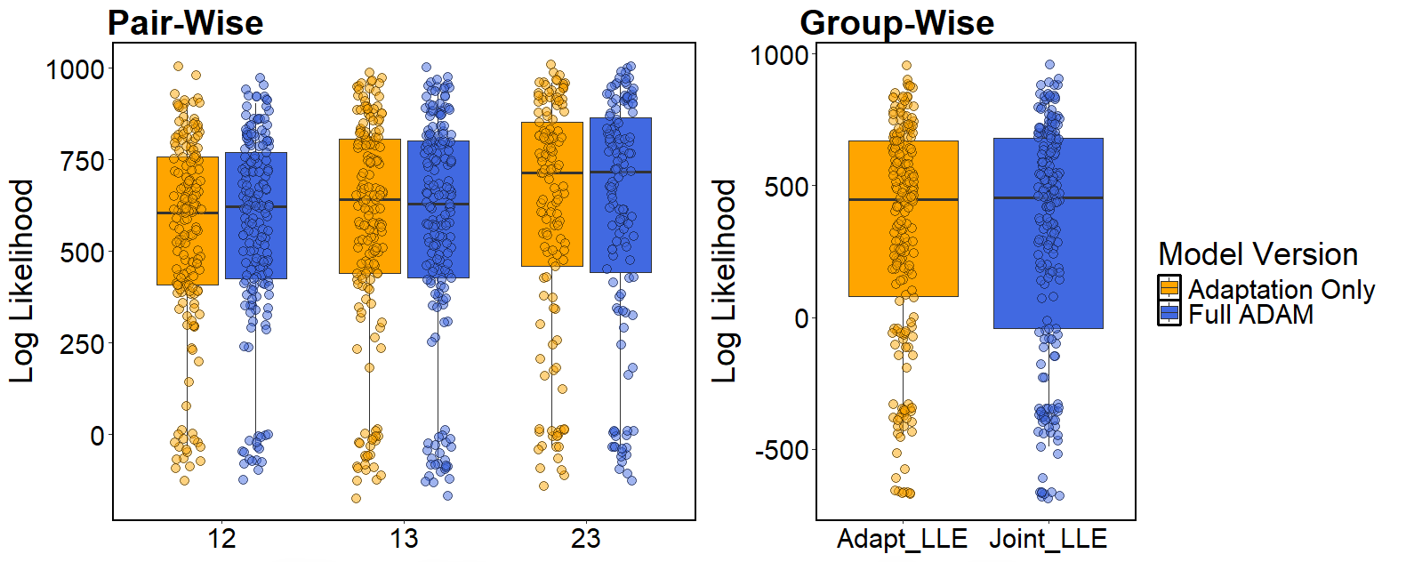

Piano & Bass

Piano & Drums

Bass & Drums



*Figure 4 displays bar plots of model fit for both the adaptation only and joint version of the ADAM. The first graph shows the log likelihood fit of the three combinations of musicians whereas the second graph displays the aggregated performance within a given group. Higher log likelihood values suggest a better model performance, though in this case, both versions performed roughly the same.*

Nonetheless, this analysis, visualized in figure 4, suggests that there is no version of the model that clearly outperforms the other. Upon immediate intuition, one might assume that this means that the adaptation only model should exclusively be used as the added complexity of the joint model does not actively improve the ADAM. However, this is not necessarily a valid conclusion, as both model versions differ structurally in how they operationalize and parameterize different cognitive processes, meaning that each provide unique value in their interpretability. For example, the adaptation only model is sufficient when exploring a tapping task in which an individual adjusts their timing to an external signal (Harry & Keller, 2019), but may fall short in fully capturing the mechanisms utilized during a complex task like music performance where various synchronization strategies are required, such as in this study. In this case, the values used for the analyses derive from completely naturalistic recordings in which musical groups performed a large variety of different pieces. This means that throughout a piece, musicians may dynamically shift the mechanisms with which they improve synchronization as the piece itself progresses. To illustrate, there may be sections of a performance where it may be best for the pianist to simply adapt to the drummer’s steady pulse when the bassist has cut out, or where anticipating the bassist’s next few beats may help the pianist synchronize unison rhythms. As the demands of the piece shift, the mechanisms used and sensorimotor cues relied upon to meet these demands likely also shift. This leads to the absence of a standout version, as both model versions provide value in understanding sensorimotor synchronization in different contexts. For this reason, results from both the adaptation only and joint ADAM models were explored in depth at the group level and pair level.

## 3.2 Group Level Synchrony

### *3.2.1 Interaction of Tempo and Complexity on Group Asynchrony*

To begin to answer the second research question exploring group synchrony (Appendix, Figure A.1) at the group level, a LMER predicting group asynchrony values using the piece complexity and tempo as fixed effects was performed, with song, artist, and performance length as random effects to account for any additional sources of variance outside of the factors of interest. The analysis found that there were no main effects of tempo or piece complexity on group asynchrony; however, there was a significant interaction between tempo and piece complexity (β = -0.0870, p < .01). As illustrated in figure 5, at faster tempi, group asynchrony decreased as piece complexity decreased, but at slower tempi, as complexity increased so too did group asynchrony. This suggests a complex relationship between piece complexity and tempo as they relate to group synchrony, with complex pieces promoting better synchrony at faster tempi, while increased complexity challenges synchrony more at slower tempi. These findings highlight the importance of considering how tempo and complexity interact when studying group coordination in musical performance. The lack of significant main effects alongside the significant interaction indicates that neither tempo nor complexity alone is sufficient to predict group synchrony. Instead, their combined effect is critical. To better understand the mechanisms behind this interaction, the next step is to investigate the distribution of the ADAM parameters as well as how piece complexity and tempo predict different parameters, which may reveal how these factors influence underlying coordination processes in group performance.

**Figure 5**

***Interaction Between Tempo and Piece Complexity on Group Asynchrony***

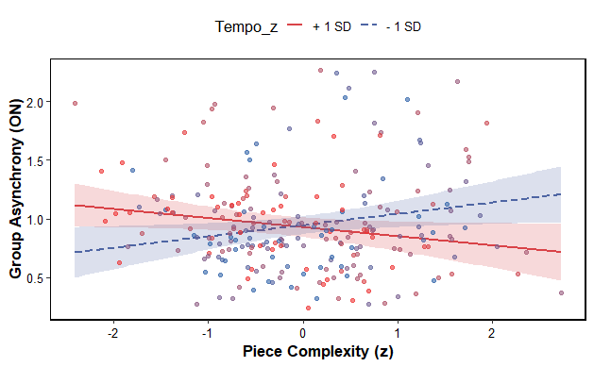

*Figure 5 graphs the interaction between tempo and piece complexity on group asynchrony scores, displaying that at faster tempi, increased piece complexity promotes better group synchrony whereas at slower tempi, it discourages group synchrony. The red values signify pieces with faster tempi and the blue values signify pieces with slower tempi.*

### *3.2.2 Distribution of ADAM Parameters*

Below, figure 6 displays the distribution of values for the parameters of both ADAM versions, providing insight into the general trend of mechanisms utilized in this naturalistic context to improve group synchrony. For the adaptation only version of the ADAM, the phase correction distribution, with a mean near 0.25 and a range of approximately -0.6 to 1.5, indicated that participants typically made modest spontaneous timing adjustments, but with high variability – including occasional under and overcorrection – suggesting an overall flexibility in this mechanism’s implementation. Period correction looked considerably different, with a mean slightly above zero and a much narrower distribution, with most values falling in between -0.1 and 0.1. This suggested that musicians made very minimal intentional tempo adjustments, suggesting limited reliance on period correction as a whole. Both timekeeper noise and motor noise had means close zero (≈0.03 and ≈0.008 respectively), suggesting that both forms of noise were minimal and that there was generally low variability, though a few large outliers indicate occasional substantial fluctuations in timing or movement execution. This may be due to the nature of live semi-improvised performance where, despite, as professionals, being very precise, levels of certainty about timing can vary and performer may occasionally make mistakes.

**Figure 6**

***Adaptation Only and Joint Model Parameter Distributions***

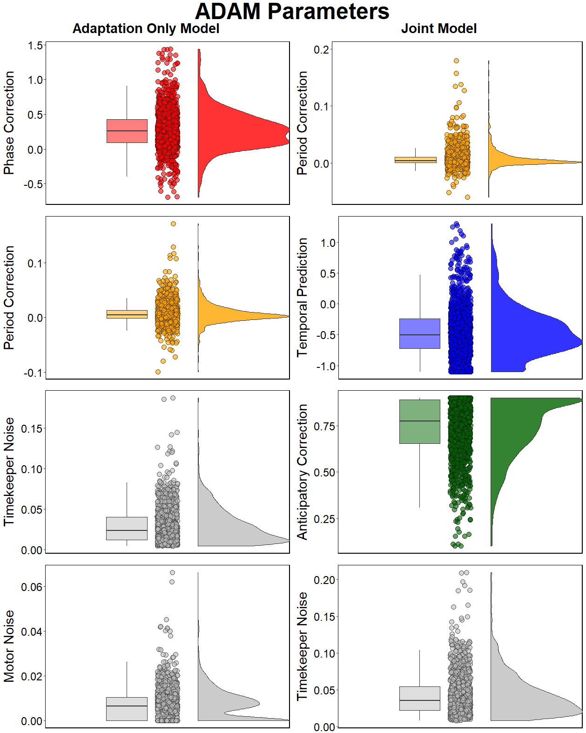

*Figure 6 compares parameter distributions from the two versions of the ADAM at the group level. Each subplot shows the spread and central tendency of each parameter using a boxplot, scatter points, and a density curve. These plots summarize the range and variability of each parameter’s contribution to timing behavior.*

When looking at the period correction distribution in context of the joint version of the ADAM, they look largely similar, apart from the fact that this distribution includes larger positive values, possibly reflecting that the models differ slightly in how they capture or implement period adjustments. The distribution of temporal prediction values was centered around -0.5 with the distribution spanning from -1 to 1, suggesting that musicians more often utilized tracking mechanisms when attempting to improve synchrony than temporal prediction, though in certain cases, prediction was used. Anticipatory correction values had a mean near 0.75 with a considerable skew towards more positive values, suggesting, as a whole, the use of strong and frequent anticipatory adjustments to improve group synchrony. Due to the nature of the calculation, anticipatory correction values could not mathematically exceed one, leading to the skew towards positive values displayed. Just as before, the timekeeper distribution, centered around 0.04, was generally low in variability apart from the few large outliers. While these distributions provide valuable insights into the overall trends and variability of the underlying mechanisms, the use of LMERs is necessary to tease apart the specific influences of tempo and piece complexity on these parameters as well as their combined effect on group asynchrony.

### *3.2.3 Predicting ADAM Parameters using Tempo and Piece Complexity*

Each of the four parameters for both versions of the ADAM was predicted using LMERS that once again included tempo and piece complexity as fixed effects, with the song and artist as random effects. It is relevant to note that the LMERs for period correction and timekeeper noise in the adaptation only model and all of the parameters for the joint model were in fact singular. A singular LMER model indicates that at least one of the random effect components has a variance estimated to be near to zero, indicating that the model is too complex for the data and may need to be simplified for reliable estimation. For the LMERs in which this occurred, a standard linear model with only fixed effects was run to assess the performance of the LMER. In all of the above cases, both analyses returned nearly identical results, suggesting that, despite their singularity, the LMERs yielded valid results. Changes in the structure of the LMERs such as the removal of different combinations of random effects also did not lead to different findings. Furthermore, due to the large amount of data being analyzed, the risk posed by singularity is reduced as larger amounts of data help to improve the models ability to estimate variance reliably (Matuschek et al., 2017). Taken together, the structure of the LMERs was left as is in order to increase the interpretability of results between models, as the singularity did not pose a threat to the validity of the results.

When looking at the adaptation-only ADAM parameters, only piece complexity was found to predict phase correction (β = 0.0696, p < 0.001), meaning that as pieces become more complex, groups rely more heavily upon phase correction to remain synchronized. This likely reflects the musicians’ adaptive attempts to maintain synchrony in the face of increased rhythmic variability, regardless of the tempo. On the other hand, there was a significant negative effect of both piece complexity (β = -0.0936, p < 0.001) and tempo (β = -0.0610, p < 0.001) on period correction indicating that groups utilize less period correction as the complexity of the piece increases and as the tempo becomes faster. This may point to an attempt by the musicians to maintain synchronization stability as a given performance becomes more demanding. When predicting timekeeper noise, it was found that as piece complexity increased so too did timekeeper noise (β = 0.3921, p < 0.001), pointing to an understandable increase in variability in the musicians’ internal timekeepers as rhythms become increasingly complex. Inversely, faster tempi were linked to reduced timekeeper noise (β = -0.1080, p < 0.05), suggesting that faster tempi improved the precision of the musicians’ internal timekeepers. These findings match a seminal study by Wing and Kristofferson (1973a) in which they showed that timekeeper variance grows as tempo decreases. This provides a necessary sanity check and helps to verify the validity of the modeling approach. Lastly, motor noise scores were predicted using the LMER, with results inferring a decrease in motor noise as tempo increases (β = -0.1349, p < .001), possibly tied to the difficulties identified with maintaining an accurate timekeeper at a slow tempo. Alternatively, this may relate to a classic motor control effect where faster tempi lead to smaller movements, which are generally linked to lower timing variability (Hove et al., 2014; Keller, Ishihara, et al., 2011). Though speculative, since movement amplitude was not measured, it offers a plausible explanation grounded in literature. Together, these findings show that as piece complexity increases, musicians rely more on phase correction, less on period correction, and experience greater timekeeper noise, while faster tempi are associated with reduced period correction, lower timekeeper noise, and decreased motor noise. Building on this, the predictive power of these factors on joint ADAM parameters will be examined to further understand group coordination dynamics and the role of anticipation in this process.

In the context of the joint ADAM, an increase in both tempo (β = -0.1013, p < 0.001) and piece complexity (β = -0.1682, p < 0.001) resulted in a decrease in the reliance on period correction, mirroring the findings reported for period correction from the adaptation only model. When exploring the role of temporal prediction on synchronization, temporal prediction was found to increase as piece complexity increased (β = 0.1376, p < 0.001), suggesting that musicians relied more heavily on predictions to help synchronize as pieces increased in complexity. Furthermore, an interaction was found between tempo and piece complexity (β = 0.1231, p < 0.01), meaning musicians exhibited even greater temporal prediction when performing complex pieces if the tempo was faster, highlighting how tempo modulates the impact complexity has on temporal prediction. As rhythmic complexity increases, musicians rely more heavily upon temporal predictions to better anticipate timing variability, especially at faster tempi where timing demands are even higher. Anticipatory correction, however, did not show any significant relationship with either piece complexity, tempo, or their interaction, suggesting that this mechanism was not actively utilized at the group level during performance. When predicting timekeeper noise using this version, increased piece complexity once again significantly raised timekeeper variability (β = 0.421, p < 0.001), while faster tempi signified a reduction (β = -0.097, p < 0.05), reinforcing the earlier sanity check and confirming the consistent influence of piece complexity and tempo on internal timing precision (Wing & Kristofferson, 1973a).

To summarize, both increasing piece complexity and faster tempi led to a reduced reliance on period correction, while temporal prediction increased with complexity—amplified further at faster tempi—and timekeeper noise rose with complexity but decreased as tempo sped up, whereas anticipatory correction showed no significant effects. Following these insights, the next step is to integrate all parameters, factors, and group asynchrony into a comprehensive analysis to uncover how their dynamic interplay collectively shapes group synchronization and the adaptor and anticipatory mechanisms underlying sensorimotor synchronization amongst jazz trio performers.

### *3.2.4 Integrated Models Predicting Group Asynchrony*

For the final integrated analysis predicting group asynchrony, two LMERs were built including piece complexity and tempo as well as all four parameters for each respective ADAM version, with song, artist, and performance length included as random effects to account for random variability. For the integrated model including adaptation only parameters, greater piece complexity significantly reduced group asynchrony (β = −0.072, p < 0.05), meaning groups better synchronized when the rhythms within a piece were more complex. This may reflect a greater level of attention to group synchrony as the demands increase for the performers or the positive effect of subdividing beats into smaller units on timing precision (Clayton et al., 2020). Tempo, inversely, did not impact group asynchrony in a meaningful manner whatsoever. Phase correction strongly improved group synchrony (β = −0.484, p < 0.001), demonstrating the importance of adaptive timing adjustment in group synchrony. The interaction between piece complexity and phase correction (β = −0.380, p < 0.001) showed that phase correction becomes even more effective in complex rhythms. Period correction, however, did not have a direct impact on group asynchrony. In contrast, timekeeper noise increased group asynchrony (β = 0.164, p < 0.001), confirming the intuition that greater internal timing variability undermines group synchronization, with the interaction of piece complexity further adding to this detriment as pieces grew more difficult (β = 0.168, p < 0.001). As tempo increased, the negative effects of timekeeper noise on group asynchrony were significantly mitigated (β = −0.167, p < 0.001). Surprisingly, motor noise was found to be associated with reduced asynchrony (β = −0.133, p < 0.01), suggesting that performers compensated for greater variability in their own movement by more vigorously implementing synchronization strategies. Together, these results show that increased rhythmic complexity can improve group synchrony even though tempo alone does not; that phase correction – namely in complex passages – is especially important; that internal timing variability disrupts synchrony especially in complex pieces unless counteracted by faster tempi; and that performers even compensate for increased motor noise. To explore the role of anticipation, this process was replicated, instead using the joint ADAM parameters.

**Figure 7**

***Group Asynchrony Residuals***

|  |  |
| --- | --- |
| **Adaptation Only Model** | **Joint Model** |
|  |  |

*Figure 7 presents the residuals for each parameter in both ADAM versions, showing the difference between observed and predicted group asynchrony values across participants. By examining the spread and distribution of these residuals, the plot provides insight into model fit, revealing which parameters were captured well by the model as well as where systematic deviations may occur in their effects on group synchrony.*

For the joint ADAM integrated analysis predicting group asynchrony, higher piece complexity again signified a decrease in group asynchrony (β = −0.138, p < 0.001), confirming that complex rhythms lead to an improvement in group synchrony, while tempo again remained non‐significant. In contrast to the previous analysis, this LMER found that a greater reliance on period correction improved synchrony (β = −0.208, p < 0.01), particularly as tempo increased (β = 0.196, p < 0.01). This may be due to the way in which error correction is modeled in the joint version of the ADAM, as temporal anticipation and timekeeper noise parameters may account for some of the minute corrections modeled by phase correction in the adaptation only version, allowing larger picture tempo corrections represented in the model by period correction to be better measured. Stronger temporal prediction also led to a decrease in group asynchrony (β = −0.296, p < 0.001), suggesting that utilizing anticipatory mechanisms effectively supports overall group synchrony. This is further supported by the finding that increased anticipatory correction also leads to a decrease in group asynchrony (β = -0.296, p < 0.001), further emphasizing the importance of anticipatory processes in this naturalistic context. Lasty, as one might expect, timekeeper noise was found to decrease group synchrony (β = 0.277, p < 0.001), particularly as rhythms became more complex (β = 0.170, p < 0.001). Figure 7 displays the residuals from both integrated models, showing how well each parameter predicts group asynchrony.

In sum, this analysis found that group synchrony improved with higher piece complexity and was significantly enhanced by greater reliance on period correction – particularly at faster tempi –, temporal prediction, and anticipatory correction, while internal timekeeper noise consistently disrupted synchrony – especially under complex rhythmic conditions. This provides a visual assessment of model fit, reflecting which factors were captured accurately and where discrepancies occurred across participants. To better understand how these dynamics and those found in all of the previous group-level analyses emerge, pair-level analyses results will be explored in order to examine how synchrony unfolds between individual performers within the group context and whether similar patterns hold across unique performer pairings.

## 3.3 Pair-Based Synchrony

### *3.3.1 Interaction of Tempo and Complexity on Pairwise Asynchrony*

Before delving into the dynamics introduced by the ADAM parameters at the individual level, it is important once again to explore the effect of the external fixed factors – in this case tempo, part complexity, and musical role. To do so, a LMER predicting pairwise asynchrony values (Appendix, Figure A.2) using tempo, part complexity, and musical role as fixed effects was utilized, with the song, artist, and performance length once again acting as random effects. Adding onto the findings of the group-level model which revealed no main effects but a significant interaction between tempo and complexity, the individual-level analysis identified significant main effects of both tempo and complexity. Specifically, faster tempi were associated with lower pairwise asynchrony (β = -0.466, p < .001), while higher part complexity predicted greater pairwise asynchrony (β = 0.085, p < .05), indicating that individuals tended to synchronize better when the musical environment was simpler and faster. The model also found that bassists and drummers experienced lower pairwise asynchrony with all other musicians than pianists with their fellow performers (Bass-Piano: β = -0.1145, p < .05; Bass-Drums: β = -0.8658, p < .001; Drums-Piano: β = -0.1388, p < .01; Drums-Bass: β = -0.9619, p < .001). This is likely due to the naturalistic nature of the jazz trios, where pianists are allowed more soloistic freedom while the bassist and drummer are jointly responsible for maintaining rhythmic stability. Particularly when exploring the relationship between bassists and drummers, this tight synchrony weakens as tempo (Bass-Drums: β = 0.1756, p < .001; Drums-Bass: β = 0.2088, p < .001) and part complexity (Bass-Drums: β = 0.2350, p < .001; Drums-Bass: β = 0.1944, p < .001) increases, possibly as a result of the increasing rhythmic demand placed upon them as a pair. The individual-level results therefore indicate an additive influence of tempo and piece complexity on pair-based synchrony, moderated by musical role. These findings are visualized in figure 8. Together, these findings highlight the need to consider both group and individual dynamics when assessing coordination, and display how musical roles within a group can modulate sensitivity to various aspects of a given performance. To further understand these mechanisms, the way in which ADAM parameters respond to tempo, complexity, and musical role will be explored, potentially illuminating the underlying cognitive mechanisms that improve synchronization in this highly naturalistic context.

**Figure 8**

***Interaction Between Musical Role and Part Complexity/Tempo on Pairwise asynchrony***

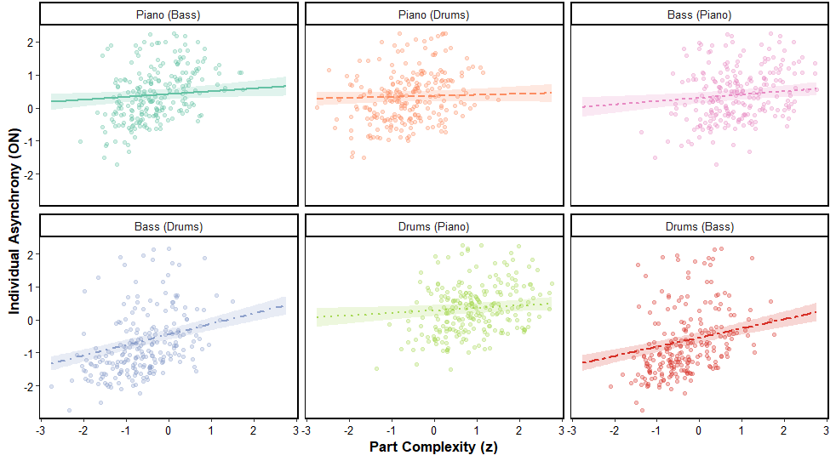

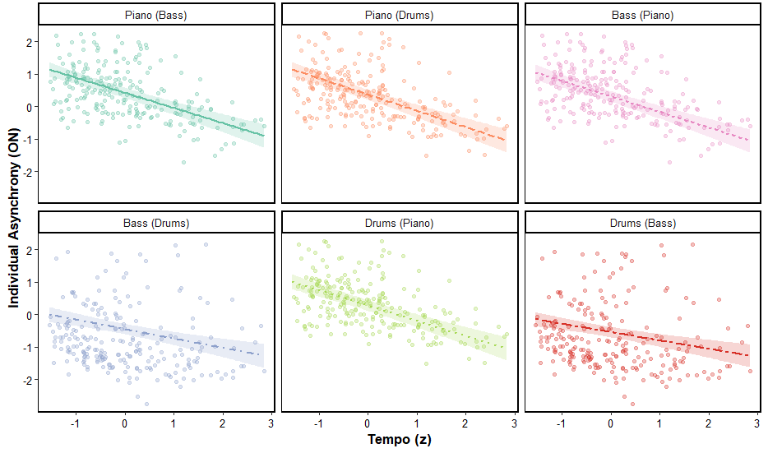

*Figure 8 graphs the interaction between synchronizing musicians and both part complexity and tempo on pairwise asynchrony scores. In the plot titles, the format Musician A (Musician B) indicates the perspective of Musician A synchronizing to Musician B.This figure displays that, when exploring the coordination between bassist and drummers, both exhibit increasingly large asynchronies with one another as piece complexity increases. It also shows that generally, as tempo increases, asynchrony decreases, though only significantly when exploring the relationship between bassists and drummers.*

### *3.3.2 Distribution of ADAM Parameters*

**Figure 9**

***Pair-Wise Adaptation Only and Joint Model Parameter Distributions***

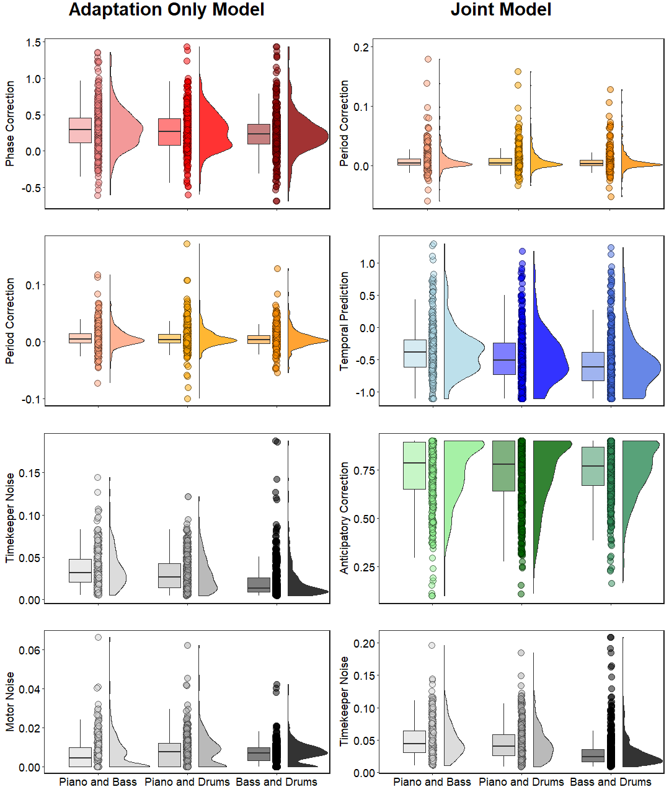

*Figure 9 compares parameter distributions from the two versions of the ADAM at the pair-wise level. Each subplot shows the spread and central tendency of each parameter using a boxplot, scatter points, and a density curve. These plots summarize the range and variability of each parameter’s contribution to timing behavior as it relates to each unique musical pairing.*

To further explore whether the coordination mechanisms differed meaningfully between different pairs of musicians, the distributions of the ADAM parameters were also examined separately for each unique pair. Interestingly, this separation of the distributions by pair revealed that the overall shapes and central tendencies of the parameter distributions remained largely consistent. This suggests that, while there may be individual differences in types of synchronization mechanisms used as well as the baseline levels of synchrony across unique pairs, the core dynamics captured by the ADAM models are robust across all performers. Namely, regardless of pair, figure 9 reveals, similar to figure 6, that, across both ADAM versions, individual synchrony was supported by flexible phase correction, minimal period correction, low timekeeper and motor noise with occasional outliers, strong and frequent anticipatory correction, a tendency toward tracking over temporal prediction, and model-specific differences in how period correction and prediction were represented. This stability in distribution implies that all three musicians in this context share a similar set of synchronization principles in this high-level naturalistic context, most likely due to their common training and understanding of music. Rather than each pair developing entirely unique ways of synchronizing, the findings point toward robust, generalizable principles of musical interaction that transcend individual pairings and reflect a collective understanding of how professional musicians achieve and maintain group synchrony in complex, naturalistic settings. Still, examining the models at the pair level remains important for understanding how individual musicians uniquely engage with the ADAM parameters and how these mechanisms interact dynamically within each pair to produce successful synchronization at the group level, starting with the adaptation only version of the ADAM.

### *3.3.3 Predicting ADAM Parameters using Tempo, Part Complexity, and Musical Role*

When predicting phase correction using pair-level linear mixed models, clear differences emerged across pairs and in response to musical contexts (Appendix, Figure A.4). Again, both bassists and drummers were found to be significantly different than pianists, as they both relied on phase correction when coordinating with all other musicians far less than pianists (Bass-Pianist: β = -0.7869, p < 0.001; Bass-Drums: β = -0.4165, p < 0.001; Drums-Piano: β = -0.9867, p < 0.001; Drums-Bass: β = -0.6838, p < 0.001), suggesting that these pairs relied less on anticipatory correction mechanisms to stay synchronized. This reduced reliance may reflect either more rigid internal timing strategies or reduced sensitivity to asynchrony feedback in these groups based on their role as the foundation of the piece’s rhythm. However, contextual factors, such as part complexity and tempo, modulated phase correction selectively across pairs, signifying the flexible use of this adaptive strategy as needed. For example, a significant positive interaction between part complexity and drummers synchronizing with bassists (β = 0.4116, p < 0.001) indicated that these musicians increased their use of phase correction to their bassist counterpart as rhythms grew in complexity, reflecting adaptive behavior similar to what was observed in the adaptation-only model at the group level. Tempo effects were also found to be musical role specific. When synchronizing between bass and drums, bassists showed a significant decrease in phase correction as tempo increased (β = -0.4177, p < 0.001), while drummers exhibited the opposite, increasing their reliance on phase correction at faster tempi (β = 0.3167, p < 0.01). This may be due to the more flexible role that bassists commonly play in jazz trios, acting both as rhythmic leaders and harmonic support based on the given context within a piece. At faster tempi, bassists may shift away from phase correction to focus more heavily on their harmonic role, while drummers, as rhythmic leaders, increase phase correction to ensure precise ensemble timing. Notably, the three-way interaction between part complexity, tempo, and bassists synchronizing with pianists (β = -0.2463, p < 0.05) revealed that they showed particularly reduced phase correction when faced with both high complexity and fast tempi, suggesting a breakdown in coupling under demanding conditions. These findings echo earlier group-level adaptation-only model results showing that complexity drives phase correction, highlighting how pair-specific strategies shape this synchronization. This further supports the importance of modeling individual pair dynamics to capture the nuanced, real-time mechanisms essential for musical performance.

Both increased part complexity (β = -0.2571, p < 0.01) and tempo (β = -0.2308, p < 0.01) led to a significant decrease in the reliance of period correction, suggesting that musicians tend to decrease their tempo adjustments when performing more complex rhythms or at faster speeds. This pattern is consistent with earlier group-level findings indicating that performers may limit tempo corrections to preserve synchronization stability in more challenging musical contexts. However, this trend was not uniform across all pairs. Namely, when exploring how drummers coordinate with bassists, there was an opposite effect, with increasing period correction as rhythmic complexity increased (interaction β = 0.3583, p < 0.01), pointing to pair-dependent flexibility in adaptive adjustments and again suggesting the key role drummers play as rhythmic leaders. Additionally, a three-way interaction involving part complexity, tempo, and bassists synchronizing with pianists (β = 0.4050, p < 0.01) revealed that they increased their period correction in response to the combined challenges of complex rhythms and faster tempi. These observations support and extend prior results, which link complexity with phase correction by underscoring how the utilization of adaptive strategies for tempo correction differs between pairs. Overall, these results highlight the critical role of both musical demands and interpersonal coordination dynamics in shaping how ensembles adapt tempo to maintain tight synchronization during performance.

Timekeeper noise decreased significantly as part complexity increased (β = -0.1923, p < 0.01), indicating that as the complexity of inter-onset intervals increases, musicians tend to exhibit less variability in their internal timekeepers. This suggests that musicians may sharpen their internal timing mechanisms when faced with more complex rhythms to maintain synchrony. Consistent with the Wing-Kristofferson timing model, tempo also showed a strong negative relationship with timekeeper noise (β = -0.4088, p < 0.001), implying that faster tempi are associated with more precise internal timing at the individual as well as group level (Wing & Kristofferson, 1973a). Notably, significant differences were observed across all of the musicians and their synchronization partners, highlighting the importance of interpersonal dynamics in the presence of timekeeper noise (Piano-Drums: β = -0.1602. p < 0.01; Bass-Pianist: β = -0.7869, p < 0.001; Bass-Drums: β = -0.4165, p < 0.001; Drums-Piano: β = -0.9867, p < 0.001; Drums-Bass: β = -0.6838, p < 0.001). Interaction effects revealed that for several musicians, such as when bassists (β = 0.1664, p < 0.05) and drummers (β = 0.1627, p < 0.05) synchronize with one another and when drummers synchronize with pianists (β = 0.1564, p < 0.05), the typical reduction in timekeeper noise with increasing part complexity was counteracted, indicating that some musicians experienced great difficulty in maintaining their internal timekeeper as complexity increased, while others did not, possibly pointing to an increased responsibility on bassists and drummers to maintain synchronization as complexity increases. Moreover, increases in tempo particularly aided bassists and drummers as they synchronized with all other musicians (Bass-Piano: β = 0.1449, p < 0.05; Bass-Drum: β = 0.2572, p < 0.001; Drums-Piano: β = 0.2421, p < 0.001; Drums-Bass: β = 0.3468, p < 0.001), suggesting that the generally observed beneficial effect of faster tempi on timekeeper precision varies substantially across pairs. Additionally, three-way interactions combining part complexity, tempo, and bassists (β = 0.1875, p < 0.05) and drummers (β = 0.1789, p < 0.05) as they synchronized with one another were significant, further emphasizing that pair-specific coordination dynamics modulate how these two factors jointly influence timekeeper noise. Together, these findings indicate that although greater part complexity and faster tempi generally correspond to decreased variability in internal timing, this relationship was particularly pronounced for bassists and drummers depending on the demands of the piece. This aligns with the group-level analysis, showing that musicians dynamically adjust to both the complexity and tempo of the music to maintain precise timing based on their inter-group partnerships during jazz performance.

When examining the predictors of motor noise, tempo emerged as a significant factor, with faster tempi associated with a reduction in motor noise (β = -0.1897, p < 0.01). This suggests that musicians tend to produce more precise motor outputs when playing at higher speeds, which supports group-level findings that increased tempi can enhance motor control and reduce variability. Particularly, pianists (β = 0.1934, p < 0.05) and drummers (β = 0.1934, p < 0.05) displayed a significantly higher level of motor noise when coordinating with one another, possibly as a result of their significantly different musical roles. Interestingly, motor noise was further increased for drummers when coordinating with pianists as tempo increased (β = 0.1946, p < 0.05), implying that the issues caused by these differing roles are exacerbated as tempo quickens, contrary to the overall trend. In addition, a three-way interaction revealed that when drummers coordinated with bassists at faster tempi with more increased part complexity, their motor noise decreased (β = -0.2472, p < 0.05), potentially reflecting an adaptive response under demanding rhythmic conditions. Together, these results reinforce the general notion at the group-level that faster tempi generally improve motor precision, but qualifies that this trend is far more nuanced and complex than first expected.

Moving to the joint version of the ADAM, both part complexity and tempo were found to be significant predictors of period correction. Specifically, increases in part complexity (β = -0.3477, p < 0.001) and tempo (β = -0.3075, *p* < 0.001) were associated with a reduction in period correction, indicating that groups adjusted their underlying tempo less as the musical context became more rhythmically complex and quicker. This mirrors the findings from the period correction parameter in the pair-based adaptation-only model analysis, further supporting the likelihood that musicians in this context limit tempo adjustments under heightened temporal demands to maintain synchronization stability. However, the implementation was not completely the same across all coordinating musicians. When synchronizing with one another, bassists (β = -0.2916, p < 0.01) and drummers (β = -0.3667, p < 0.001) demonstrated significantly lower levels of period correction, implying they more often intentionally adjust their tempo in relation to each other. Furthermore, there was pair-specific flexibility based on various factors inherent to the performance. For instance, the negative effect of part complexity on period correction was tampered when drummers synchronized with bassists (β = 0.3250, p < 0.05), suggesting that this group maintained or even enhanced their period correction in complex contexts. Similarly, positive interactions between tempo and drummers synchronizing with pianists (β = 0.2990, p < 0.01) revealed that, in this context, drummers increasingly utilized tempo adjustments at faster speeds, potentially to compensate for synchronization difficulties. Furthermore, bassists coordinating with pianists exhibited a significant three-way interaction (β = 0.2571, p < 0.05), reflecting increased period correction under the dual pressure of high part complexity and fast tempo, suggesting again that the use of this mechanism may be compensatory for the increased difficulty of synchronization. Together with findings from the adaptation only model, these findings emphasize that while period correction tends to decrease under more demanding musical conditions, some musicians display dynamic, context-sensitive adaptation strategies, namely in the face of increased performance difficulty, reinforcing the idea that various musical demands and goals modulate the use of tempo adjustments in joint musical performance.

Both part complexity (β = 0.2694, p < 0.01) and tempo (β = 0.1754, p < 0.05) significantly increased temporal prediction, indicating that performers relied more heavily on predictive mechanisms when faced with higher rhythmic complexity and faster tempi. This aligns with previous findings that increased complexity increases the need for anticipatory processing in order to maintain coordination. Additionally, pianists coordinating with drummers (β = -0.2671, p < 0.01), bassists with drummers (β = -0.3982, p < 0.001), and drummers with bassists (β = -0.3664, p < 0.001) all exhibited significantly reduced temporal prediction, highlighting stable differences in anticipatory strategies between specific musicians and who the synchronize with. However, these trends were moderated by various contextual dynamics. Significant interactions revealed that when drummers synchronized with bassists, the typical increase of temporal prediction with increased part complexity was inhibited (β = -0.2255, p < 0.05). Musician-specific effects were also observed, with bassists (β = -0.3982, p < 0.001) and drummers (β = -0.3664, p < 0.001) exhibiting significantly reduced temporal prediction when coordinating with one another, highlighting individual differences in anticipatory strategies based on musical role. This reduced reliance on temporal prediction was also found for pianists synchronizing with drummers (β = -0.2671, p < 0.01), exacerbated at faster tempos, where temporal prediction was used even more sparingly (β = -0.2706, p < 0.01). Inversely, drummers also relied less heavily upon this prediction as tempo increased when coordinating with pianists (β = -0.3949, p < 0.001). Furthermore, part complexity and tempo jointly impacted drummers as they synchronized with pianists (β = 0.2441, p < 0.05) and bassists (β = 0.2632, p < 0.05), indicating that, while faster tempi alone hindered prediction for this pairing, the combined presence of increased part complexity reversed this effect, possibly as a result of the greater complexity of rhythms allowing for clearer timing markers and thus improving predictions. Temporal prediction emerges here as a flexible mechanism that is selectively amplified depending on the interaction between musical context and pair dynamics. These results reinforce the idea that temporal prediction is a core adaptive process in sensorimotor synchronization, dynamically modulated by both global musical parameters and local interpersonal coordination mechanisms.

In examining anticipatory correction within the model, part complexity demonstrated a significant positive effect (β = 0.2087, p < 0.01), indicating that as rhythmic complexity increased, musicians relied more on anticipatory mechanisms such as self-other integration to synchronize. Tempo on its own showed no reliable impact on anticipatory correction, but there was a significant interaction between rhythmic complexity and tempo (β = -0.1798, p < 0.05), suggesting that faster tempi tend to reduce the positive influence of rhythmic complexity on anticipatory correction. Moreover, significant differences emerged across musician pairs, with bassists and drummers exhibiting greater levels of anticipatory correction when coordinating with all other musicians (Bass-Piano: β = 1.0613, p < 0.01; Bass-Drums: β = 0.5236, p < 0.001; Drums-Piano: β = 1.0738, p < 0.001; Drums-Bass: β = 0.5648, p < 0.001). Notably, for bassists (β = -0.2821, p < 0.01) and drummers (β = -0.3037, p < 0.01) coordinating with pianists, this effect was reversed as part complexity increased, indicating a decreased effect of complexity for these pairs. This reversal was further modulated by tempo, as the three-way interactions involving part complexity, tempo, and these synchronizing musicians were significant (Bass-Piano: β = 0.2929, p < 0.01; Drums-Piano: β = 0.3224, p < 0.01), implying that at faster tempi, the reduction in anticipatory correction due to complexity was counteracted. These findings suggest that while anticipatory correction, and thus self-other integration, generally increases with rhythmic complexity, the tempo can dampen this effect overall but may restore or even amplify it in specific pairings. This pair-specific modulation points to nuanced interpersonal dynamics in how musicians implement attention control and self-other integration under varying musical demands, complementing earlier findings where tempo and complexity jointly influenced synchronization processes.

In the joint models attempt to predict timekeeper noise, increased part complexity (β = -0.2851, p < 0.001) and tempo (β = -0.4254, p < 0.001) also significantly decreased timekeeper noise, reinforcing prior evidence that faster tempi and increased complexity independently correspond to more precise internal timing. Again, significant differences across musician pairs were evident, with bassists (β = -0.8864, p < 0.001) and drummers (β = -0.7944, p < 0.001) exhibiting notably lower timekeeper noise when synchronizing, aligning with previous findings highlighting the importance of interpersonal dynamics in timing variability, particularly for bassists and drummers. Interaction effects between part complexity and synchronizing musicians were almost identical to the findings when predicting timekeeper noise using the adaptation only model (Bass-Piano: β = 0.1313, p < 0.05; Drums-Piano: β = 0.2029, p < 0.01; Drums-Bass: β = 0.1836, p < 0.01) as well as between tempo and musical role (Bass-Piano: β = 0.1616, p < 0.01; Bass-Drums: β = 0.1802, p < 0.01; Drums-Piano: β = 0.2565, p < 0.001; Drums-Bass: β = 0.3417, p < 0.001). Overall, these results corroborate previous findings, underscoring that both complexity and tempo systematically shape internal timing variability while being modulated by interpersonal synchronization dynamics. While it is valuable to explore the ADAM parameters and fixed effects separately to understand their individual contributions, a comprehensive understanding of how they jointly influence asynchrony requires integrating both sets of predictors within a single LMER, the results of which are explored in figure 10 and the text below.

### *3.3.4 Integrated Models Predicting Pairwise Asynchrony*

As previously established, faster tempi (β = -0.466, p < .001) and lower part complexity (β = 0.085, p < .05) were associated with lower individual asynchronies, with bassists and drummers generally synchronized more tightly than pianists. These factors, however, uniquely shaped the impact that the various adaptive strategies had on musicians’ efforts to better coordinate and reduce interpersonal asynchrony. Phase correction’s impact upon pairwise asynchrony, as an example, was lower for bassists and drummers compared to pianists (Bass–Piano: β = -0.7869, p < .001; Bass–Drums: β = -0.4165, p < .001; Drums–Piano: β = -0.9867, p < .001; Drums–Bass: β = -0.6838, p < .001), suggesting that these roles may have relied less on reactive correction to improve synchrony than pianists. The impact of these mechanisms was more pronounced when drummers coordinated with bassists as part complexity increased, likely as a response to the shared increase in rhythmic demands placed on the drummer and the bassist (β = 0.4116, p < .001). Conversely, when bassists coordinated with pianists, reliance on phase correction was associated with worse asynchrony at faster tempi (β = -0.4177, p < .001), suggesting a reduced effectiveness of adaptive timing during quick pieces. This effect was exacerbated as both tempo and part complexity increased, further supporting that bassists shifted away from error correction as their individual demands grew (β = -0.2463, p < .05). In contrast, drummers coordinating with pianists showed improved synchrony with increased phase correction at faster tempi (β = 0.3167, p < .01), indicating that drummers were better able to implement adaptive adjustments under tempo pressure. Period correction was also shaped by these factors. Overall, both increasing part complexity (β = -0.2571, p < .01) and faster tempi (β = -0.2308, p < .01) were again associated with reduced period correction. However, in certain dyads, increased period correction was beneficial. Drummers synchronized better with increased period correction when coordinating with bassists under high complexity (β = 0.3583, p < .01), and bassists synchronized better with increased period correction under both high complexity and fast tempi when playing with pianists (β = 0.4050, p < .01). Based on this, these findings demonstrate that musicians strategically adjust their use of adaptive timing mechanisms based on both their role and their musical context to maintain synchronization in the face of varying demands.

Internal timekeeper noise decreased with increasing part complexity (β = -0.1923, p < .01) and faster tempi (β = -0.4088, p < .001), suggesting that these task demands helped to stabilize musicians’ internal timekeepers. However, this stabilization did not translate uniformly to improved coordination. Role-specific interactions showed that greater timekeeper noise particularly predicted worse synchronization outcomes for bassists and drummers synchronizing with one another (Bass-Piano: β = 0.1664, p < .05; Drums-Bass: β = 0.1627, p < .05) as well as drummers synchronizing with pianists (β = 0.1564, p < .05). Notably, for bassists (β = 0.2572, p < .001) and drummers (β = 0.3468, p < .001) synchronizing with one another, this impact was amplified with rising tempi, confirming that even minute internal variability can impact synchrony under more challenging conditions. Additionally, bassists (β = 0.1449, p < .05) and drummers (β = 0.2421, p < .001) synchronizing with pianists were vulnerable to this effect, with a further impact of timekeeper noise on synchrony as part complexity increased in coordination with tempo (Bass-Piano: β = 0.1875, p < .05; Drums-Piano: β = 0.1789, p < .05), suggesting that increased task demands magnified the influence of internal variability. Motor noise also declined with increasing tempo (β = -0.1897, p < .01), indicating greater motor precision under faster pacing. Yet, pianists coordinating with drummers exhibited a greater impact of motor noise on pairwise asynchrony (β = 0.1934, p < .05), with further increases at faster tempi (β = 0.1946, p < .05), again linking elevated noise with poorer synchrony. In contrast, drummers coordinating with bassists showed a reduced impact of motor noise under high tempi and complexity (β = -0.2472, p < .05), implying that drummers successfully implemented motor adaptation in this context. Collectively, these findings, displayed in figure 10, confirm that although task demands generally suppressed noise, the extent to which this translated into improved performance depended critically on musical role and dyadic configuration, highlighting the relevance of ADAM parameters in shaping real-world coordination success.

**Figure 10**

***Pairwise Asynchrony Residuals***

|  |  |
| --- | --- |
| **Adaptation Only Model** | **Joint Model** |
|  |  |

*Figure 10 presents the residuals for each parameter in both ADAM versions, showing the difference between observed and predicted pairwise asynchrony values. By examining the spread and distribution of these residuals, the plot provides insight into model fit, revealing which parameters were captured well by the model as well as where systematic deviations may occur in their effects on synchrony at the musician level.*

Moving to the implementation of the joint ADAM parameters into the integrated LMER, bassists displayed a significant benefit from greater period correction in synchronization when playing with pianists (β = 0.4050, p < .01), suggesting that they were able to strategically leverage this adaptive mechanism to maintain synchrony. Drummers also benefited from greater period correction when coordinating with bassists under high complexity (β = 0.3583, p < .01), implying an adaptive use of period correction when rhythmic demands were heightened. In contrast, the impact of temporal prediction was generally reduced with increasing part complexity (β = -0.1682, p < .01) and tempo (β = -0.2183, p < .001), suggesting a diminished proactive adjustment as demands grow. In conjunction with the previous findings, this suggests a possible shift from anticipatory to adaptive strategies as demands grew. To further support this, when bassists coordinated with pianists, greater temporal prediction resulted in worse asynchrony at faster tempi (β = -0.4177, p < .001). Inversely, drummers benefited from increased temporal prediction at fast tempi when playing with pianists (β = 0.3167, p < .01), highlighting role-specific flexibility in anticipatory strategies. Anticipatory correction was also shaped by musical context, with higher complexity and tempo reducing its impact upon synchrony (β = -0.1426, p < .05; β = -0.1967, p < .01), though drummers synchronizing with bassists showed improved synchrony with greater anticipatory correction under these same conditions (β = 0.3372, p < .01), possibly reflecting efficient attentional control mechanisms when attending to bassists. Timekeeper noise again decreased with both complexity (β = -0.1923, p < .01) and tempo (β = -0.4088, p < .001), suggesting enhanced internal stability under greater demand. Yet, this apparent stabilization did not always yield better coordination. Increased timekeeper noise predicted worse synchrony for bassists and drummers playing together (Bass-Drum: β = 0.2572, p < .001; Drum-Bass: β = 0.3468, p < .001), with this effect further amplified at faster tempi (β = 0.1881, p < .01), underscoring the persistent vulnerability of these dyads to internal timing fluctuations and changing responsibilities. Furthermore, as complexity and tempo jointly increased, timekeeper noise had an even greater detrimental impact on the synchrony of bassists and drummers with pianists (Bass-Piano: β = 0.1875, p < .05; Drums-Piano: β = 0.1789, p < .05). Taken together, these results, visualized in figure 10, emphasize that although task demands broadly constrained anticipatory mechanisms and suppressed noise, musicians’ ability to coordinate depended largely on their role, the context of their performance, and the specific combination of timing strategies they employed.

## 3.4 Interpreting Collective Findings

Synthesizing the findings across the group and pairwise analyses reveals a number of important parallels and distinctions that help clarify the broader implications of this study, while also illustrating the nuanced dynamics of synchronization in naturalistic musical performance. At both levels, increasing tempo was generally associated with tighter synchrony and reduced internal noise, while increased part complexity tended to amplify variability, though this effect was often role and context dependent. Both group and pairwise models showed both adaptation and anticipation mechanisms played crucial roles in enhancing synchrony, particularly under high complexity, though their effectiveness varied across specific performer dyads. For instance, group-level models emphasized the general benefits of phase correction and temporal prediction, while pair-level analyses revealed that these same mechanisms were selectively engaged depending on the pairing and musical role, such as drummers increasing phase correction with faster tempi, or bassists reducing their reliance on phase correction under the same conditions. Similarly, while timekeeper and motor noise were found to disrupt synchrony at both levels, the extent of their impact was more sharply defined in the pairwise models, where noise effects often emerged through specific interactions between musical role, tempo, and part complexity. Importantly, the group-level integrated models emphasized average trends across all performances, providing a global view of synchronization strategies, whereas the pair-level analyses uncovered nuanced adaptive behaviors and anticipatory strategies that differed meaningfully across dyads. Despite these differences, the convergence of results across levels supports the robustness of the ADAM framework in capturing shared synchronization principles while also highlighting the critical role of interpersonal dynamics and role-specific strategies in fine-tuning group synchrony. These complementary perspectives are necessary to fully understand how synchronization unfolds in real-world musical settings without ignoring group-level trends or obscuring interpersonal strategies that make group synchrony possible.

# 4. Discussion

This study explored the mechanisms that enable musicians to maintain synchrony during jazz trio performance – namely adaptation, anticipation, and attentional control. By analyzing behavioral data from real-world recordings of piano, bass, and drum performances, the study sought to model the cognitive strategies that underlie dynamic coordination in naturalistic group contexts. The following discussion is structured to systematically unpack and contextualize these findings. First, the ADAM model results are interpreted in detail, comparing the adaptation-only and joint model versions and identifying the mechanistic drivers of synchronization in jazz trio settings. Next, these findings are situated within the broader literature on the ADAM and musical coordination, highlighting extensions beyond dyadic contexts and the model’s application to naturalistic performance data. The discussion then turns to the practical implications of the results for understanding expert jazz trio performance, including how different timing strategies are flexibly deployed. Broader implications for group music making are explored in the subsequent section, with a focus on cognitive strategies for multi-person synchronization and the relevance of these mechanisms to social motor coordination more generally. Finally, limitations of the current study are acknowledged and possible directions for future research are proposed, including methodological extensions, model refinements, and cross-genre comparisons.

## 4.1 Interpretation of ADAM Model Results in Jazz Trios

### *4.1.1 Model Comparison: Adaptation-Only vs. Joint ADAM*

The comparison between the adaptation-only and joint versions of the ADAM highlights how different timing mechanisms contribute uniquely to group coordination. The adaptation-only ADAM focused on reactive strategies, capturing phase correction and period correction which are both essential for responding to timing discrepancies as they arise. The joint ADAM version expanded upon this by incorporating anticipatory strategies, specifically temporal prediction and anticipatory correction, which allow performers to proactively adjust their timing based on expected future events. Despite yielding largely similar fits to the data, the two models differed meaningfully in the insights they offered due to their distinct parameter structures. The inclusion of anticipatory mechanisms in the joint ADAM model provided a more nuanced view of coordination, particularly under conditions where temporal structure was less predictable. These results align with findings from dyadic interaction studies that suggest that anticipatory strategies become increasingly important when rhythmic stability is reduced (Jacoby et al., 2015; Van Der Steen & Keller, 2013). Together, this means that, while both models are effective, the joint ADAM model is better suited for capturing the nuanced dynamics of group synchronization in complex musical contexts such as jazz trio performance.

### *4.1.2 Mechanistic Drivers of Synchronization*

The results provide a detailed profile as to how different cognitive mechanisms contribute to successful musical coordination, offering deeper insight into the adaptive, anticipatory, and attentional strategies musicians use to stay synchronized in performance contexts. Among these, phase correction stood out as the most consistently applied mechanism, particularly under conditions of high rhythmic complexity, both at the group and pairwise level. This suggests that musicians rely heavily on fast, automatic error correction to adjust to timing fluctuations in real time. This is unsurprising as this strategy is well-documented in prior work emphasizing the importance of reactive synchronization in musical performance (Keller, 2008; Repp & Keller, 2004). Interestingly, the implementation of this mechanism was modulated by musical role. Drummers tended to increase their use of phase correction at faster tempi, likely reflecting their leadership role in maintaining tempo and driving the performance forward rhythmically. In contrast, bassists reduced their reliance on phase correction at faster speeds, possibly adopting a stabilizing function to anchor the group as the harmonic and rhythmic connection between the pianist and drummer. This pattern of role-specific modulation supports and extends the idea that musicians strategically adapt their use of reactive mechanisms depending on their task demands and performance role (Hadley et al., 2015; Jacoby et al., 2021; Keller et al., 2014; Wing et al., 2014).

These findings underscore the significant impact that musical role has on both synchronization outcomes and the selection of timing strategies. Across performances, bassists and drummers generally exhibited lower pairwise asynchrony when coordinating with other musicians compared to pianists, likely reflecting their foundational roles in supporting the rhythmic structure of the piece. Pianists, by contrast, occupy soloistic positions and appear to rely more heavily on adaptive and anticipatory strategies to integrate with the ensemble. Notably, the tight synchrony observed between bassists and drummers weakened as both tempo and complexity increased, suggesting that while these roles provide a strong rhythmic core, this dyad becomes more relaxed under more demanding conditions. Each synchronization mechanism, whether adaptive or anticipatory, was shaped not just by global performance factors like tempo or complexity, but by who was coordinating with whom. These role-specific patterns reveal a highly dynamic interplay between internal timing control and group context.

Period correction showed a very different pattern in its application from phase correction. Across both model versions, period correction values decreased as rhythmic complexity and tempo increased. This finding implies that under cognitively demanding conditions performers tend to minimize tempo changes to preserve overall ensemble coherence—consistent with observations made by Repp (2005) that large-scale timing adjustments can often be destabilizing under heavy cognitive load. However, a more nuanced picture emerged from the joint ADAM model, where higher values were associated with better synchronization at fast tempi. This suggests that, though it may not be regularly implemented, when musicians do engage in period correction under high-speed conditions, it can be particularly effective in maintaining long-range alignment. These results suggest that there are context-sensitive benefits to the implementation of period correction. While performers generally avoid it under stress, they can strategically deploy it to effectively preserve synchrony as needed.

The anticipatory mechanisms included in the joint ADAM model offered further insights into the implementation of forward planning in group synchronization. Temporal prediction increased significantly with both rhythmic complexity and tempo, suggesting that musicians supplement reactive strategies with predictive estimations in more challenging contexts. This aligns closely with the dual-route model by Keller (2012), in which musicians combine automatic entrainment with effortful prediction when demands are high. These results also confirm broader research showing that anticipation is not uniformly applied but instead emerges when reactive mechanisms alone are insufficient (Demos et al., 2012; Demos et al., 2019; Pecenka & Keller, 2011). Anticipatory correction, on the other hand, did not show strong modulation by complexity or tempo, but it was associated with improved overall synchrony. This suggests that this strategy may be applied more selectively, potentially utilized only in moments where musicians predict a significant asynchrony. Such behavior is consistent with Konvalinka et al. (2010), who observed anticipatory corrections in joint tapping tasks when one performer consistently predicted the timing of their partner, allowing for smoother interpersonal coordination. This selective use of anticipatory correction likely reflects underlying shifts in attentional control between self-based timing and external cues from other musicians.

Lastly, the noise parameters – timekeeper noise and motor noise – provided critical information about the internal variability that can disrupt synchrony. Timekeeper noise increased with complexity, indicating that cognitively demanding passages are more susceptible to timing inconsistencies in mental representations of the beat. Interestingly, both timekeeper and motor noise decreased as tempo increased, suggesting that faster tempi encourage more automatic and rhythmically entrained performance, reducing variability. These findings are consistent with the classic Wing and Kristofferson (1973a) model and later studies by Schulze et al. (2005), which link increased timing variability to internal processes rather than simply motor execution. Moreover, both forms of noise were significant predictors of increased asynchrony, underscoring the essential role of precise internal timing for maintaining coordination. This reinforces conclusions from Semjen et al. (2000), who emphasized that stable interpersonal synchrony is not only about strategic corrections but also hinges on minimizing variability at both cognitive and motor levels. Importantly, these findings may be shaped by the improvisatory nature of jazz, which introduces greater moment-to-moment uncertainty and spontaneity. Keller, Weber, et al. (2011) found that improvisation increases timing variability compared to rehearsed performance, potentially making synchronization more challenging. A related strategy, discussed by Wolf et al. (2019), suggests that combining phase advancement and period correction can compensate for increased motor noise and help preserve synchrony, particularly in complex joint rhythmic activities such as this.

In sum, the dynamics of synchrony in jazz trios reflect a complex interplay between external musical factors, musician roles, and adaptive interpersonal coordination strategies. Tempo and part complexity significantly influence synchrony, with faster tempi generally reducing pairwise asynchrony, while greater complexity tends to increase it. These effects, however, are moderated by musical roles: bassists and drummers—tasked with maintaining rhythmic stability—typically exhibit tighter synchrony compared to pianists, who enjoy more soloistic freedom. Although the core principles of synchronization modeled by ADAM remain largely consistent across musician pairs, the deployment and effectiveness of specific adaptive and anticipatory timing mechanisms—such as phase correction, period correction, temporal prediction, and anticipatory correction—are highly flexible and context-dependent. The research reveals that increased demands, such as higher complexity and faster tempi, can sometimes challenge coordination or diminish the effectiveness of certain strategies, yet these conditions also prompt compensatory adaptations within specific dyads that help sustain synchrony. While task demands generally suppress internal timekeepers and motor noise, the negative impact of such noise on synchronization can be amplified in particular pairings and under challenging conditions, especially at faster tempi and greater complexity, highlighting the sensitivity of certain interpersonal configurations to timing variability. Underlying this flexibility is the role of attention control, as musicians dynamically shift focus between self-generated timing and external cues from their partners to maintain alignment. Ultimately, successful synchrony in naturalistic jazz performance is not governed by fixed parameters alone but requires musicians to strategically adjust their timing strategies in response to both overarching musical demands and the specific dynamics of their partners.

## 4.2 Connections to Prior ADAM and Synchronization Research

### *4.2.1 Extending Dyadic ADAM Research*

The current findings significantly extend prior applications of the ADAM framework by demonstrating its validity in more complex, ecologically realistic musical settings. Earlier work with dyads identified phase correction and period correction as the primary mechanisms supporting interpersonal synchrony (Harry & Keller, 2019). The results support these earlier conclusions but reveal that ensemble performance, particularly in jazz trios, demands a broader range of timing strategies. While phase correction remains foundational, namely under fluctuating rhythmic conditions, anticipatory mechanisms such as temporal prediction become increasingly essential when the music becomes faster and more complex. In contrast to dyadic settings where real-time reactive adjustments often suffice, trio performance creates an environment where prediction is not just helpful, but oftentimes necessary to maintain tight coordination among multiple musicians acting simultaneously.

Further support for this comes from parallels between the jazz trio data and results from dual-agent simulations using ADAM, where leader–follower dynamics naturally emerged when only one agent employed anticipatory processes (Harry & Keller, 2019). In these models, synchrony was optimized when functional asymmetries – when one performer primarily anticipated and the other primarily adapted – were present. This dynamic was mirrored in the empirical findings, where role-specific differences in temporal prediction and anticipatory correction suggest that real musicians in trios similarly adopt differentiated roles. For instance, drummers and bassists appeared to engage in more anticipatory behavior when paired with pianists, while showing greater reliance on adaptation when working together. This supports the idea that the asymmetrical use of timing strategies within an ensemble is not a breakdown of synchrony, but a functional adaptation to shared musical responsibilities. It also points to the potential of ADAM to capture not only individual synchronization tendencies, but also how musicians strategically distribute cognitive load within a group using both self-other integration and self-other segregation. These findings reinforce the flexibility and scalability of the ADAM model beyond the dyad for studying group synchrony in realistic, interactive contexts.

### *4.2.2 Linking Computational Models with Naturalistic Music Performance*

Beyond extending dyadic applications, this study contributes to a growing body of research that seeks to bridge computational modeling of cognitive processes and naturalistic music performance. Traditional models of coordination such as coupled oscillator frameworks and attention-based synchronization systems have emphasized dynamic coupling, entrainment, and role-dependent timing (Earl & Strogatz, 2003; Heggli et al., 2019; Heggli et al., 2021). While these models offer elegant mathematical explanations of coordination, they often stop short of directly linking theoretical mechanisms such as adaptation, anticipation, and attention control to observable behavior in real-world settings. The ADAM model offers a crucial complement by exploring synchrony at the cognitive level, introducing more direct interpretability through parameters that are grounded in psychological constructs, enabling researchers to map behavioral data directly onto mental processes. This interpretability becomes especially valuable when attempting to understand the dynamics leading to synchrony in more natural musical contexts. Most prior uses of ADAM have involved tightly controlled tasks, such as tapping studies with simple rhythms, metronomic pacing, and minimal interaction between performers (Harry & Keller, 2019; Harry et al., 2023; Van der Steen, Jacoby, et al., 2015). In contrast, this study applies ADAM to complex, unstructured jazz trio recordings characterized by expressive freedom, variable timing, and overlapping musical roles. This marks a methodological step forward in using cognitive models to understand real-world ensemble interaction.

By successfully fitting ADAM to this kind of data, its robustness and flexibility has been confirmed, as well as its potential to capture nuanced coordination dynamics that may at times be flattened or obscured in controlled experiments. In doing so, this work answers recent calls by D’Ausilio et al. (2015), Heggli et al. (2019), and Demos and Palmer (2023) for computational models that extend beyond dyads and laboratory settings into ecologically valid performance contexts. Jazz trios are a particularly compelling application, as jazz trio performance demands constant mutual adaptation, contains subtle but important leadership shifts, and offers a mix of predictability and improvisation unique to the genre. The ADAM's ability to model these dynamics suggests that cognitive-based computational models can serve as powerful tools for understanding group interaction not only in music, but in other joint action contexts, opening new pathways for analyzing the interplay between structure, agency, and collaboration in time-sensitive group behavior (Kimmel, 2021; Vesper et al., 2013; Zamm et al., 2023).

## 4.3 Implications for Naturalistic Jazz Trio Performance

The results reveal that expert jazz musicians do not rely on a single timing mechanism but rather flexibly shift between adaptive and predictive strategies depending on the musical context. Phase and period correction served as key mechanisms for synchrony; however, as the complexity of the piece or the tempo increased, musicians increasingly relied on anticipatory strategies to maintain synchrony. This flexible blending of mechanisms highlights a dynamic and context-sensitive approach to timing that mirrors the dynamic nature of jazz performance itself. This aligns with previous findings, where expert performers were shown to dynamically reweight their sensorimotor strategies as the demands of the musical environment changed (Demos et al., 2014; Pecenka & Keller, 2011). Moreover, the way these strategies were deployed varied markedly by musical role, reinforcing functional specialization within the context of jazz performance specifically. Drummers consistently showed elevated phase correction at faster tempi, reflecting their role as timekeepers responsible for maintaining rhythmic synchrony. Bassists, in contrast, displayed decreased phase correction and increased period correction in more demanding contexts, suggesting a stabilizing role in the ensemble, acting as a bridge between the rhythmic consistency of the drums and the harmonic freedom of the piano. Pianists demonstrated the greatest variability in synchronization behaviors, consistent with their expressive and autonomous role in jazz trio performance. These patterns support and extend prior observations of role-asymmetries in group coordination, suggesting that musicians don’t just synchronize to a shared pulse (Chang et al., 2017; Demos et al., 2019; Jacoby et al., 2021; Keller et al., 2016; Wing et al., 2014). This suggests that they strategically distribute synchronization responsibilities largely based upon their musical roles within a given piece. Such differentiation also allows the trio to fluidly respond to shifts in musical leadership, tempo, and texture without individuals losing cohesion through overcorrections and ill-made predictions.

Another key implication of the results lies in how jazz musicians balance adaptation and anticipation via attention control during group performance. Adaptive mechanisms emerged as default, low-cost mechanisms for maintaining synchrony with minimal cognitive effort. In contrast, anticipatory strategies were only implemented when the musical context demanded tighter coupling and more forward-planning. This pattern reflects what Vesper et al. (2010) describe as coordination smoothers – strategies that individuals adopt under challenging conditions to facilitate joint action. In the present findings, these smoothers may take the form of reduced motor noise, increased phase correction, or attentionally anchored synchronization at faster tempi. This selective deployment of predictive mechanisms supports the view that musicians reserve cognitively expensive strategies for high-demand situations. This is consistent with Konvalinka et al. (2010), who found that anticipatory adjustment tends to surface primarily in contexts that require particularly close coordination. Increased synchrony during more complex pieces suggests that attentional mechanisms play a crucial role in mediating these synchrony mechanisms. Rather than becoming overwhelmed by difficult passages, expert jazz performers appeared to engage more deeply with both their own output and that of their peers. This intensified attentional engagement likely supports more effective predictions, allowing performers to stay in sync even when the overall rhythmic structure becomes unpredictable. These findings align with the theory of “integrative attending” developed by Keller (2012), in which successful synchronization depends on the performer’s ability to shift attention between self-generated motor plans and the incoming cues from others. Rather than choosing one attentional focus, performers in the jazz trios appear to rotate between these sources, using both to update timing estimates in real time. In naturalistic jazz trio contexts, the genre’s improvisatory nature often requires moment-to-moment recalibration – not just of when to play, but of how to engage with the group (Faraco et al., 2024). At times, a performer must take the lead, producing clear timing cues for their peers to follow, while, at other times, they must fall back and adapt to the direction established by another. This push–pull between leadership and followership is not random; instead, it is facilitated by a nuanced understanding of each player’s role, musical cues, and the strategic deployment of synchronization mechanisms. Ultimately, these results highlight that maintaining tight coordination in jazz trios is not simply a matter of mechanical correction but a dynamic process of cognitive resource allocation, role negotiation, and inter-group responsiveness.

## **4.4 Broader Implications for Group Music Making**

### ***4.4.1 Cognitive*** *Strategies for Multi-Person Synchronization*

The results offer insight beyond the context of jazz trios, illustrating how musicians manage the complex cognitive demands of synchronizing with multiple partners simultaneously during group music making as a whole. More broadly, the results suggest that group synchrony scales in size through strategic simplification. Rather than attempting to monitor and respond equally to all partners, performers appear to engage in selective attention, prioritizing the timing of key individuals while allowing indirect alignment to occur due to the intertwining of these pairwise relationships across the broader group. This reflects a process of attentional streamlining that helps maintain stability in dynamic group music making scenarios. These findings, in conjunction with Shahal et al. (2020), suggest that individuals in group music making contexts may tune their internal timing with the help of certain partners while disengaging from unhelpful cues and conflicting signals in order to stabilize their synchronization patterns. This is supplemented by additional findings showing that as group size increases, overall timing stability can actually improve. Dotov et al. (2022) found that when drummers performed in larger groups – from dyads to octets – timing variability decreased, suggesting that an increase in available cues allows individuals to better integrate into the group rhythm through this attentional anchoring to key individuals.

This anchoring appears to follow structured, role-based strategies. Musicians often prioritize a single partner – in the case of jazz trios, the drummer – while remaining loosely coupled to others, enabling more efficient coordination. This mechanism was mirrored in experimental studies where two followers synchronized more accurately when instructed to follow a single leader, while the direct follower-to-follower coupling remained weak (Ogata et al., 2019). Similar patterns of this multidirectional dependency between performers during group music making tasks have been documented in more formal ensembles as well. In a study of string quartets, Timmers et al. (2014) identified a consistent “chain” of influence, in which each performer focused attention on one or two core partners, creating an anchored coupling network. These results, combined with those from the present study, reinforce the idea that successful multi-person synchronization is not achieved through equal engagement with all members, but through a simplified, hierarchical structure of dependencies shaped by role, attention, and musical context. This attentional structure then shapes the synchronization mechanisms that are activated or suppressed – for instance, when and where adaptive and anticipatory mechanisms are predominantly relied upon. It would be valuable in future work to explore how these anchored networks scale in larger naturalistic performance contexts such as jazz big bands and symphony orchestras as well as how shifts in these network structures influence the synchronization strategies musicians use to achieve synchrony across different group sizes.

### *4.4.2 From Sensorimotor Synchrony to Social Motor Synchrony*

The mechanisms underlying synchrony in group music making – particularly in complex ensemble contexts – offer valuable insight into broader cognitive processes involved in social interaction. Predicting a partner’s timing requires attending to relevant behavioral cues, a demand reflected in the increased implementation of anticipatory strategies under challenging musical conditions **(Pecenka et al., 2013; Pecenka & Keller, 2011; Van der Steen, Jacoby, et al., 2015)**. These results display the importance of internal cognitive models that help individuals anticipate others' timing at the social motor level, reflected in the theory of "shared internal models" **(Keller, 2008; Keller, 2012)**. Synchrony across broad contexts depends on individuals forming partially overlapping representations of each other’s intentions and timing, enabling smoother joint action without the need for constant feedback. This view also resonates with distributed cognition perspectives, which frame coordination not as the work of isolated individuals, but as a process distributed across people, tasks, and tools in the environment (Hutchins, 1995). Understanding how these individuals’ function in real-time synchronization using these models offers a pathway to exploring how joint action unfolds in other domains of social life beyond music.

Critically, effective coordination in music and, by extension, other joint activities, requires a careful balance between integrating the information and intentions of others while maintaining one’s own contributions (Keller et al., 2016). This balance of self–other integration and segregation is essential for successful joint performance (Sabharwal et al., 2024). The adaptive strategies observed in the current study, such as selective attention, adaptive error correction, and predictive modeling, are not limited to musical contexts. Instead, they reflect domain-general mechanisms that also support coordination in activities like dance, sports, and turn taking behaviors like conversation (Kimmel, 2021; Vesper et al., 2013; Zamm et al., 2023). Indeed, research on joint action more broadly has shown that shared intentionality, coupled with mechanisms for prediction and error monitoring, underlies effective interpersonal coordination **(Sebanz et al., 2006; Vesper et al., 2017; Vesper & Sevdalis, 2020)**. These findings reinforce the notion that temporal alignment, whether through mutual adaptation or structured anticipation, is a fundamental cognitive tool for fostering social cohesion (Launay et al., 2016; Rennung & Göritz, 2016; Repp & Su, 2013; Savage et al., 2021b). As shown, group music making not only serves artistic and communicative purposes, but also serves as a window into how humans align minds and bodies in time to achieve shared goals.

## **4.5 Limitations and Future Directions**

**While the present study offers valuable insights into the dynamic cognitive mechanisms underlying group synchronization, several limitations highlight opportunities for future research to build a more comprehensive understanding of synchrony during group music making. First, the generalizability of these findings is inherently limited by the exclusive focus on jazz trios. While jazz provides a rich context for studying timing flexibility and improvisation, it represents only one format of musical collaboration (Clayton et al., 2020). To better understand the extent of application of these mechanisms, future work should test similar models in a wider variety of musical settings, including classical chamber ensembles, popular music groups, and non-Western performance traditions. Such comparative work could reveal how genre-specific conventions, cultural expectations, and structural features of music influence the balance between adaptive and anticipatory strategies as well as whether different styles favor particular synchronization mechanisms.**

**Another important limitation is the exclusive reliance on behavioral measures. Although ADAM is a powerful tool for modeling cognitive timing processes, it captures only the observable outputs of internal computations, without directly measuring their neural correlates. As a result, the model can describe what happens in synchronization but not fully explain how these processes are produced and modulated within the brain. Integrating ADAM with neurophysiological methods such as electroencephalogram (EEG), functional magnetic resonance imaging (fMRI), or magneto-encephalography (MEG) methods could offer valuable insights into the brain networks involved in adaptation, anticipation, and attention control in group music making contexts. Studies by** Keller et al. (2014) **and** Novembre et al. (2016)**, for instance, have already shown how interpersonal coordination is supported by sensorimotor and fronto-parietal systems and work on sensorimotor synchronization with virtual partners has identified brain networks associated with specific ADAM parameters (Harry et al., 2023). Future work could use similar techniques to link ADAM’s parameter estimates to neural activation patterns in real time, expanding upon current findings within the literature.**

**Beyond measurement constraints, the internal architecture of ADAM also reflects certain simplifying assumptions. The model assumes stable internal representations of time and relatively linear correction processes, which may not adequately capture the dynamic and context-sensitive nature of real-time improvisation. In spontaneous performance, musicians often make non-linear adjustments based on memory, emotion, or evolving musical structure. To account for these complexities, future modeling efforts could explore alternative frameworks such as Bayesian inference, which allows for the probabilistic updating of expectations (Cannon, 2021; Chater et al., 2010; Lee, 2018), or reinforcement learning, which models how agents adjust strategies based on cumulative outcomes (Brasoveanu & Dotlačil, 2021; Eckstein et al., 2021; Lockwood & Klein-Flügge, 2021). These approaches may be especially useful for understanding how musicians adapt their timing strategies over the course of a full performance or across repeated interactions.**

**In addition, while the present findings clearly reveal role-dependent behavior, the ADAM framework does not currently model musical role dynamics explicitly. While musical role emerges from the data itself, they are not incorporated into the ADAM’s structure. Incorporating modules capable of detecting emergent leadership, shared leadership, or fluid role-switching could enhance the ecological validity of future models. Such functionality would allow researchers to simulate more realistic group behaviors, particularly in ensembles where leadership is not fixed but distributed or negotiated in real time. This limitation calls for the integration of multiple modeling frameworks to form a more holistic account of group coordination. A hybrid approach that combines ADAM’s cognitively interpretable parameters with dynamical systems models such as coupled oscillators could bridge the gap between individual-level cognition and group-level structure (Heggli et al., 2019; Heggli et al., 2021). This would enable researchers to simultaneously capture how internal processes like prediction and error correction operate within individuals, and how these processes interact across ensemble members to produce emergent group dynamics. Such integrative models could support a more comprehensive theory of collective synchronization that reflects the continuous interplay between mental representations, sensory-motor systems, and the social architecture of performance. Ultimately, this line of work has the potential to illuminate not only how musicians synchronize, but how humans more broadly coordinate thought and action.**

# 5. Conclusion

This study set out to investigate how musicians stay in sync during group music making, particularly in naturalistic jazz trios where timing is flexible, roles shift, and coordination is often unspoken, by extending the ADaptation and Anticipation Model (ADAM) to group and pair-level behavioral data derived from the Jazz Trio Database. The central objective was to determine whether the ADAM and its cognitive parameters – phase correction, period correction, temporal prediction, and anticipatory correction, timekeeper noise, and motor noise – could effectively model and predict synchronization within and across individuals in a group setting. By doing so, the study aimed to reveal how the cognitive strategies underpinning musical synchrony unfold not only at the group level but also between pairs of performers under varying performance demands.

To address the first research question, model fit was assessed across both the adaptation-only and joint versions of ADAM. Contrary to expectations, no single version of the model consistently outperformed the other across all combinations of tempo, complexity, and musical role. Instead, both model versions provided unique interpretative value. The adaptation-only model proved sufficient for describing synchronization through adaptive error correction, whereas the joint model revealed additional anticipatory processes important for maintaining coherence in dynamically shifting musical contexts. This suggests that the cognitive mechanisms driving musical coordination are not fixed, but rather fluid and context-sensitive, requiring complementary modeling approaches to capture their full range.

The second research question focused on identifying which ADAM parameters best predicted group asynchrony and how tempo and piece complexity modulated these effects. Results showed that greater piece complexity, possibly due to increased event density, reliably improved group synchrony, while tempo had no consistent main effect. Phase correction – especially under complex rhythmic conditions – emerged as a central mechanism for maintaining synchrony, while increased timekeeper noise disrupted coordination unless mitigated by faster tempi. In the joint model, anticipatory mechanisms such as temporal prediction and anticipatory correction also strongly enhanced group synchrony, underscoring the role of predictive processes in successful group performance. These findings highlight that precise group timing emerges not from a single strategy but from a dynamic interplay between reactive and predictive timing adjustments, modulated by the demands of the musical context.

The third research question extended this analysis to the pair level to explore whether pairwise synchronization between individual performers reflected similar patterns. Indeed, many group-level findings were mirrored at the dyadic level. Faster tempi improved synchrony, while greater part complexity introduced challenges, particularly for rhythmically central pairings such as bassists and drummers. Importantly, the influence of ADAM parameters was highly role-specific. Drummers increased phase correction with faster tempi, while bassists reduced theirs, pointing to strategic role-based adaptations. Likewise, temporal prediction was selectively employed depending on pairing and context, with anticipatory correction rising under complex conditions. These nuanced results demonstrate that performers tailor their synchronization strategies based on both their musical role and their partner’s behavior, revealing that group synchrony is an emergent process shaped by local interpersonal adaptations.

Taken together, the results of this thesis paint a comprehensive picture of how real-world musical coordination is accomplished. Musicians do not rely on a singular mechanism to stay in sync, but instead draw flexibly from a repertoire of adaptive and anticipatory strategies implemented dynamically using attentional control. These strategies are continuously modulated by performance demands such as tempo and complexity, as well as by role-specific expectations and interpersonal dynamics. Importantly, the findings underscore the value of computational cognitive modeling in uncovering the latent processes that guide group music making behavior in naturalistic settings.

This study ultimately helps to reveal the cognitive machinery behind shared rhythmic experience. Synchronization in group music making can be understood as the temporal alignment of minds – an emergent property of individuals dynamically adjusting to one another in real time. By identifying specific mechanisms like adaptory correction, anticipatory prediction, and attentional control, this study provides a mechanistic explanation for how music fosters social bonding. Musical synchrony is not simply a surface-level behavioral phenomenon but rather a reflection of deep cognitive coordination. On a broader level, this work links micro-level adjustments to macro-level expression. The findings show how individuals become a group in time, forging cohesion and mutual understanding through sound. Group music making thus emerges as a form of distributed intelligence, where meaning and expression is constructed moment by moment through shared timing. It is this temporal interdependence that transforms a trio of individuals into a unified musical collective. In doing so, this research provides a critical bridge between the immediacy of interpersonal synchrony and the enduring human impulse to create meaning together through music (Schiavio & De Jaegher, 2017). It offers a framework for understanding how fleeting sensorimotor alignments scale into the profound cultural rituals that have accompanied human societies across time and place. This study shows that beneath the surface of group music making lies a dynamic cognitive architecture for collective coordination – an architecture that transforms milliseconds into meaning.

# References

Alderisio, F., Lombardi, M., Fiore, G., & di Bernardo, M. (2016). Study of movement coordination in human ensembles via a novel computer-based set-up. *arXiv preprint arXiv:1608.04652*.

Anderson, J. R. (2013). *The adaptive character of thought*. Psychology Press.

Bates, D. (2016). lme4: Linear mixed‐effects models using Eigen and S4. *R package version*, *1*, 1.

Brasoveanu, A., & Dotlačil, J. (2021). Reinforcement Learning for Production‐Based Cognitive Models. *Topics in Cognitive Science*, *13*(3), 467-487.

Brown, V. A. (2021). An introduction to linear mixed-effects modeling in R. *Advances in Methods and Practices in Psychological Science*, *4*(1), 2515245920960351.

Böck, S., Korzeniowski, F., Schlüter, J., Krebs, F., & Widmer, G. (2016). Madmom: A new python audio and music signal processing library. Proceedings of the 24th ACM international conference on Multimedia,

Cannon, J. (2021). Expectancy-based rhythmic entrainment as continuous Bayesian inference. *PLOS Computational Biology*, *17*(6), e1009025.

Chang, A., Livingstone, S. R., Bosnyak, D. J., & Trainor, L. J. (2017). Body sway reflects leadership in joint music performance. *Proceedings of the National Academy of Sciences*, *114*(21), E4134-E4141.

Chater, N., Oaksford, M., Hahn, U., & Heit, E. (2010). Bayesian models of cognition. *Wiley Interdisciplinary Reviews: Cognitive Science*, *1*(6), 811-823.

Chauvigné, L. A., Walton, A., Richardson, M. J., & Brown, S. (2019). Multi-person and multisensory synchronization during group dancing. *Human Movement Science*, *63*, 199-208.

Cheston, H., Schlichting, J. L., Cross, I., & Harrison, P. M. C. (2024). Jazz Trio Database: Automated Annotation of Jazz Piano Trio Recordings Processed Using Audio Source Separation. *Transactions of the International Society for Music Information Retrieval*. <https://doi.org/10.5334/tismir.186>

Christensen, J., Slavik, L., Nicol, J. J., & Loehr, J. D. (2023). Alpha oscillations related to self-other integration and distinction during live orchestral performance: A naturalistic case study. *Psychology of music*, *51*(1), 295-315.

Clayton, M., Jakubowski, K., Eerola, T., Keller, P. E., Camurri, A., Volpe, G., & Alborno, P. (2020). Interpersonal entrainment in music performance: theory, method, and model. *Music Perception: An Interdisciplinary Journal*, *38*(2), 136-194.

Colley, I. D., Keller, P. E., & Halpern, A. R. (2018). Working memory and auditory imagery predict sensorimotor synchronisation with expressively timed music. *Quarterly Journal of Experimental Psychology*, *71*(8), 1781-1796. <https://doi.org/10.1080/17470218.2017.1366531>

D’Ausilio, A., Novembre, G., Fadiga, L., & Keller, P. E. (2015). What can music tell us about social interaction? *Trends in Cognitive Sciences*, *19*(3), 111-114.

De Jaegher, H., & Di Paolo, E. (2007). Participatory sense-making: An enactive approach to social cognition. *Phenomenology and the cognitive sciences*, *6*, 485-507.

Demos, A. P., Chaffin, R., Begosh, K. T., Daniels, J. R., & Marsh, K. L. (2012). Rocking to the beat: effects of music and partner's movements on spontaneous interpersonal coordination. *Journal of Experimental Psychology: General*, *141*(1), 49.

Demos, A. P., Chaffin, R., & Kant, V. (2014). Toward a dynamical theory of body movement in musical performance. *Frontiers in Psychology*, *5*, 477.

Demos, A. P., Layeghi, H., Wanderley, M. M., & Palmer, C. (2019). Staying Together: A Bidirectional Delay–Coupled Approach to Joint Action. *Cognitive science*, *43*(8), e12766-n/a. <https://doi.org/10.1111/cogs.12766>

Demos, A. P., & Palmer, C. (2023). Musical synchrony, dynamical systems and information processing: Merger or redundancy? *Trends in Cognitive Sciences*, *27*(12), 1107-1108.

Dotov, D., Delasanta, L., Cameron, D., Large, E., & Trainor, L. (2022). Collective dynamics support group drumming, reduce variability, and stabilize tempo drift. *eLife*, *11*. <https://doi.org/10.7554/eLife.74816>

Dumas, G., de Guzman, G. C., Tognoli, E., & Kelso, J. A. (2014). The human dynamic clamp as a paradigm for social interaction. *Proc Natl Acad Sci U S A*, *111*(35), E3726-3734. <https://doi.org/10.1073/pnas.1407486111>

Earl, M. G., & Strogatz, S. H. (2003). Synchronization in oscillator networks with delayed coupling: A stability criterion. *Physical Review E*, *67*(3), 036204.

Eckstein, M. K., Wilbrecht, L., & Collins, A. G. (2021). What do reinforcement learning models measure? Interpreting model parameters in cognition and neuroscience. *Current opinion in behavioral sciences*, *41*, 128-137.

Edwards, D., Dixon, S., & Benetos, E. (2023). PiJAMA: Piano Jazz with Automatic MIDI Annotations. *Transactions of the International Society for Music Information Retrieval*. <https://doi.org/10.5334/tismir.162>

Faraco, A., Schwarz, A., Vincent, C., Susini, P., Ponsot, E., & Canonne, C. (2024). Listening behaviors and musical coordination in collective free improvisation. *Music & Science*, *7*, 20592043241257023.

Fink, L. K., Alexander, P. C., & Janata, P. (2022). The Groove Enhancement Machine (GEM): A Multi-Person Adaptive Metronome to Manipulate Sensorimotor Synchronization and Subjective Enjoyment. *Front Hum Neurosci*, *16*, 916551. <https://doi.org/10.3389/fnhum.2022.916551>

Goupil, L., Saint-Germier, P., Rouvier, G., Schwarz, D., & Canonne, C. (2020). Musical coordination in a large group without plans nor leaders. *Scientific Reports*, *10*(1), 20377. <https://doi.org/10.1038/s41598-020-77263-z>

Grahn, J. A., Bauer, A.-K. R., & Zamm, A. (2021). Is neural entrainment to rhythms the basis of social bonding through music? *Behavioral and Brain Sciences*, *44*, e73, Article e73. <https://doi.org/10.1017/S0140525X20001296>

Greenberg, D. M., Decety, J., & Gordon, I. (2021). The social neuroscience of music: Understanding the social brain through human song. *American Psychologist*, *76*(7), 1172.

Hadley, L. V., Novembre, G., Keller, P. E., & Pickering, M. J. (2015). Causal Role of Motor Simulation in Turn-Taking Behavior. *The Journal of Neuroscience*, *35*(50), 16516. <https://doi.org/10.1523/JNEUROSCI.1850-15.2015>

Hajnal, A., & Durgin, F. H. (2023). How frequent is the spontaneous occurrence of synchronized walking in daily life? *Exp Brain Res*, *241*(2), 469-478. <https://doi.org/10.1007/s00221-022-06536-y>

Harry, B., & Keller, P. E. (2019). Tutorial and simulations with ADAM: an adaptation and anticipation model of sensorimotor synchronization. *Biol Cybern*, *113*(4), 397-421. <https://doi.org/10.1007/s00422-019-00798-6>

Harry, B. B., Margulies, D. S., Falkiewicz, M., & Keller, P. E. (2023). Brain networks for temporal adaptation, anticipation, and sensory-motor integration in rhythmic human behavior. *Neuropsychologia*, *183*, 108524. <https://doi.org/10.1016/j.neuropsychologia.2023.108524>

Heathcote, A., Brown, S. D., & Wagenmakers, E.-J. (2015). An introduction to good practices in cognitive modeling. *An introduction to model-based cognitive neuroscience*, 25-48.

Heggli, O. A., Cabral, J., Konvalinka, I., Vuust, P., & Kringelbach, M. L. (2019). A Kuramoto model of self-other integration across interpersonal synchronization strategies. *PLOS Computational Biology*, *15*(10), e1007422.

Heggli, O. A., Konvalinka, I., Kringelbach, M. L., & Vuust, P. (2021). A metastable attractor model of self–other integration (MEAMSO) in rhythmic synchronization. *Philosophical Transactions of the Royal Society B: Biological Sciences*, *376*(1835), 20200332. <https://doi.org/10.1098/rstb.2020.0332>

Honisch, J. J., Elliott, M. T., Jacoby, N., & Wing, A. M. (2016). Cue properties change timing strategies in group movement synchronisation. *Scientific Reports*, *6*(1), 19439. <https://doi.org/10.1038/srep19439>

Hove, M. J., Balasubramaniam, R., & Keller, P. E. (2014). The time course of phase correction: a kinematic investigation of motor adjustment to timing perturbations during sensorimotor synchronization. *Journal of Experimental Psychology: Human Perception and Performance*, *40*(6), 2243.

Hutchins, E. (1995). *Cognition in the Wild*. MIT press.

Jacoby, N., Polak, R., & London, J. (2021). Extreme precision in rhythmic interaction is enabled by role-optimized sensorimotor coupling: analysis and modelling of West African drum ensemble music. *Philosophical Transactions of the Royal Society B*, *376*(1835), 20200331.

Jacoby, N., Tishby, N., Repp, B. H., Ahissar, M., & Keller, P. E. (2015). Parameter Estimation of Linear Sensorimotor Synchronization Models: Phase Correction, Period Correction, and Ensemble Synchronization. *Timing & Time Perception*, *3*(1-2), 52-87. <https://doi.org/https://doi.org/10.1163/22134468-00002048>

Kahl, S., & Kopp, S. (2018). A predictive processing model of perception and action for self-other distinction. *Frontiers in Psychology*, *9*, 2421.

Keller, P. (2014). Ensemble Performance: Interpersonal Alignment of Musical Expression. In *Expressiveness in music performance: Empirical approaches across styles and cultures* (pp. 0). Oxford University Press. <https://doi.org/10.1093/acprof:oso/9780199659647.003.0015>

Keller, P. E. (2001). Attentional Resource Allocation in Musical Ensemble Performance. *Psychology of music*, *29*(1), 20-38. <https://doi.org/10.1177/0305735601291003>

Keller, P. E. (2008). Joint action in music performance. *Enacting intersubjectivity*, 205-221.

Keller, P. E. (2012). Mental imagery in music performance: underlying mechanisms and potential benefits. *Ann N Y Acad Sci*, *1252*, 206-213. <https://doi.org/10.1111/j.1749-6632.2011.06439.x>

Keller, P. E. (2014). Ensemble performance: Interpersonal alignment of musical expression. *Expressiveness in music performance: Empirical approaches across styles and cultures*, *1*, 260-282.

Keller, P. E. (2023). Integrating theory and models of musical group interaction. *Trends in Cognitive Sciences*, *27*(12), 1105-1106.

Keller, P. E., & Appel, M. (2010). Individual Differences, Auditory Imagery, and the Coordination of Body Movements and Sounds in Musical Ensembles. *Music Perception*, *28*(1), 27-46. <https://doi.org/10.1525/mp.2010.28.1.27>

Keller, P. E., & Burnham, D. K. (2005). Musical meter in attention to multipart rhythm. *Music Perception*, *22*(4), 629-661.

Keller, P. E., Dalla Bella, S., & Koch, I. (2010). Auditory imagery shapes movement timing and kinematics: evidence from a musical task. *Journal of Experimental Psychology: Human Perception and Performance*, *36*(2), 508.

Keller, P. E., Ishihara, M., & Prinz, W. (2011). Effects of feedback from active and passive body parts on spatial and temporal parameters in sensorimotor synchronization. *Cognitive processing*, *12*, 127-133.

Keller, P. E., Novembre, G., & Hove, M. J. (2014). Rhythm in joint action: psychological and neurophysiological mechanisms for real-time interpersonal coordination. *Philosophical Transactions of the Royal Society B: Biological Sciences*, *369*(1658), 20130394. <https://doi.org/10.1098/rstb.2013.0394>

Keller, P. E., Novembre, G., & Loehr, J. (2016). 14 musical ensemble performance: representing self, other and joint action outcomes. *Shared representations: Sensorimotor foundations of social life*, 280.

Keller, P. E., Weber, A., & Engel, A. (2011). Practice makes too perfect: Fluctuations in loudness indicate spontaneity in musical improvisation. *Music Perception*, *29*(1), 109-114.

Kimmel, M. (2021). The Micro-Genesis of Interpersonal Synergy. Insights from Improvised Dance Duets. *Ecological Psychology*, *33*(2), 106-145. <https://doi.org/10.1080/10407413.2021.1908142>

Konvalinka, I., Vuust, P., Roepstorff, A., & Frith, C. D. (2010). Follow you, Follow me: Continuous Mutual Prediction and Adaptation in Joint Tapping. *Quarterly Journal of Experimental Psychology*, *63*(11), 2220-2230. <https://doi.org/10.1080/17470218.2010.497843>

Koul, A., Ahmar, D., Iannetti, G. D., & Novembre, G. (2023). Interpersonal synchronization of spontaneously generated body movements. *iScience*, *26*(3), 106104. <https://doi.org/https://doi.org/10.1016/j.isci.2023.106104>

Large, E., & Grondin, S. (2008). Resonating to Musical Rhythm: Theory and Experiment. *Psychol Time*, 189-232. <https://doi.org/10.1016/B978-0-08046-977-5.00006-5>

Launay, J., Tarr, B., & Dunbar, R. I. (2016). Synchrony as an adaptive mechanism for large‐scale human social bonding. *Ethology*, *122*(10), 779-789.

Lee, M. D. (2018). Bayesian methods in cognitive modeling. *The Stevens’ handbook of experimental psychology and cognitive neuroscience*, *5*, 37-84.

Leongómez, J. D., Havlíček, J., & Roberts, S. C. (2022). Musicality in human vocal communication: an evolutionary perspective. *Philosophical Transactions of the Royal Society B*, *377*(1841), 20200391.

Lockwood, P. L., & Klein-Flügge, M. C. (2021). Computational modelling of social cognition and behaviour—a reinforcement learning primer. *Social Cognitive and Affective Neuroscience*, *16*(8), 761-771.

Loehr, J. D., Kourtis, D., Vesper, C., Sebanz, N., & Knoblich, G. (2013). Monitoring individual and joint action outcomes in duet music performance. *Journal of Cognitive Neuroscience*, *25*(7), 1049-1061.

MacDonald, R. (2021). The social functions of music: Communication, wellbeing, art, ritual, identity and social networks (C-WARIS). In *Routledge international handbook of music psychology in education and the community* (pp. 5-20). Routledge.

MacRitchie, J., Herff, S. A., Procopio, A., & Keller, P. E. (2018). Negotiating between individual and joint goals in ensemble musical performance. *Quarterly Journal of Experimental Psychology*, *71*(7), 1535-1551. <https://doi.org/10.1080/17470218.2017.1339098>

Marr, D., & Poggio, T. (1976). From understanding computation to understanding neural circuitry.

*MATLAB*.In. (2020). (Version Version 2020a) [[Computer Software]]. The Math Works, Inc. <https://www.mathworks.com/>

Matuschek, H., Kliegl, R., Vasishth, S., Baayen, H., & Bates, D. (2017). Balancing Type I error and power in linear mixed models. *Journal of memory and language*, *94*, 305-315.

Mills, P. F., Harry, B., Stevens, C. J., Knoblich, G., & Keller, P. E. (2019). Intentionality of a co-actor influences sensorimotor synchronisation with a virtual partner. *Q J Exp Psychol (Hove)*, *72*(6), 1478-1492. <https://doi.org/10.1177/1747021818796183>

Milne, A. J., Dean, R. T., & Bulger, D. (2023). The effects of rhythmic structure on tapping accuracy. *Attention, Perception, & Psychophysics*, *85*(8), 2673-2699. <https://doi.org/10.3758/s13414-023-02778-2>

Néda, Z., Ravasz, E., Brechet, Y., Vicsek, T., & Barabási, A. L. (2000). The sound of many hands clapping. *Nature*, *403*(6772), 849-850. <https://doi.org/10.1038/35002660>

Novembre, G., Sammler, D., & Keller, P. E. (2016). Neural alpha oscillations index the balance between self-other integration and segregation in real-time joint action. *Neuropsychologia*, *89*, 414-425.

Ogata, T., Katayama, T., & Ota, J. (2019). Cross-feedback with Partner Contributes to Performance Accuracy in Finger-tapping Rhythm Synchronization between One Leader and Two Followers. *Scientific Reports*, *9*(1), 7800. <https://doi.org/10.1038/s41598-019-43352-x>

Ono, K., Nakamura, A., & Maess, B. (2015). Keeping an eye on the conductor: neural correlates of visuo-motor synchronization and musical experience [Original Research]. *Frontiers in Human Neuroscience*, *Volume 9 - 2015*. <https://doi.org/10.3389/fnhum.2015.00154>

Pacherie, E. (2012). 14 the phenomenology of joint action: Self-agency versus joint agency. *Joint attention: New developments in psychology, philosophy of mind, and social neuroscience*, 343.

Pecenka, N., Engel, A., & Keller, P. E. (2013). Neural correlates of auditory temporal predictions during sensorimotor synchronization. *Front Hum Neurosci*, *7*, 380. <https://doi.org/10.3389/fnhum.2013.00380>

Pecenka, N., & Keller, P. (2009a). Auditory Pitch Imagery and Its Relationship to Musical Synchronization. *Annals of the New York Academy of Sciences*, *1169*, 282-286. <https://doi.org/10.1111/j.1749-6632.2009.04785.x>

Pecenka, N., & Keller, P. (2009b). The relationship between auditory imagery and musical synchronization abilities in musicians. ESCOM 2009: 7th Triennial Conference of European Society for the Cognitive Sciences of Music,

Pecenka, N., & Keller, P. E. (2011). The role of temporal prediction abilities in interpersonal sensorimotor synchronization. *Experimental Brain Research*, *211*, 505-515.

Peterson, R. A. (2021). Finding optimal normalizing transformations via bestNormalize.

Peterson, R. A., & Cavanaugh, J. E. (2020). Ordered quantile normalization: a semiparametric transformation built for the cross-validation era. *Journal of applied statistics*.

Rasch, R. A. (1988). Timing and synchronization in ensemble performance.

Rennung, M., & Göritz, A. S. (2016). Prosocial consequences of interpersonal synchrony. *Zeitschrift für Psychologie*.

Repp, B. H. (2005). Sensorimotor synchronization: A review of the tapping literature. *Psychonomic Bulletin & Review*, *12*, 969-992.

Repp, B. H., & Keller, P. E. (2004). Adaptation to tempo changes in sensorimotor synchronization: effects of intention, attention, and awareness. *Q J Exp Psychol A*, *57*(3), 499-521. <https://doi.org/10.1080/02724980343000369>

Repp, B. H., & Keller, P. E. (2008). Sensorimotor synchronization with adaptively timed sequences. *Hum Mov Sci*, *27*(3), 423-456. <https://doi.org/10.1016/j.humov.2008.02.016>

Repp, B. H., & Su, Y.-H. (2013). Sensorimotor synchronization: a review of recent research (2006–2012). *Psychonomic Bulletin & Review*, *20*, 403-452.

RStudio Team, P. (2020). *RStudio: Integrated Development for R*.In RStudio. <http://www.rstudio.com/>

Sabharwal, S. R., Breaden, M., Volpe, G., Camurri, A., & Keller, P. E. (2024). Leadership dynamics in musical groups: Quantifying effects of musical structure on directionality of influence in concert performance videos. *PLOS ONE*, *19*(4), e0300663. <https://doi.org/10.1371/journal.pone.0300663>

Savage, P. E., Loui, P., Tarr, B., Schachner, A., Glowacki, L., Mithen, S., & Fitch, W. (2021a). Toward inclusive theories of the evolution of musicality. *Behavioral and Brain Sciences*, *44*.

Savage, P. E., Loui, P., Tarr, B., Schachner, A., Glowacki, L., Mithen, S., & Fitch, W. T. (2021b). Music as a coevolved system for social bonding. *Behavioral and Brain Sciences*, *44*, e59.

Schiavio, A., & De Jaegher, H. (2017). Participatory sense-making in joint musical practice. In *The Routledge companion to embodied music interaction* (pp. 31-39). Routledge.

Schmidt, R. C., Fitzpatrick, P., Caron, R., & Mergeche, J. (2011). Understanding social motor coordination. *Human Movement Science*, *30*(5), 834-845. <https://doi.org/https://doi.org/10.1016/j.humov.2010.05.014>

Schulze, H.-H., Cordes, A., & Vorberg, D. (2005). Keeping Synchrony While Tempo Changes: Accelerando and Ritardando. *Music Perception*, *22*(3), 461-477. <https://doi.org/10.1525/mp.2005.22.3.461>

Schwartze, M., Tavano, A., Schröger, E., & Kotz, S. A. (2012). Temporal aspects of prediction in audition: Cortical and subcortical neural mechanisms. *International Journal of Psychophysiology*, *83*(2), 200-207. <https://doi.org/https://doi.org/10.1016/j.ijpsycho.2011.11.003>

Schwarz, A., Faraco, A., Vincent, C., Susini, P., Ponsot, E., & Canonne, C. (2025). Covert variations of a musician’s loudness during collective improvisation capture other musicians’ attention and impact their interactions. *Proceedings B*, *292*(2039), 20242623.

Sebanz, N., Bekkering, H., & Knoblich, G. (2006). Joint action: bodies and minds moving together. *Trends in Cognitive Sciences*, *10*(2), 70-76.

Semjen, A., Schulze, H.-H., & Vorberg, D. (2000). Timing precision in continuation and synchronization tapping. *Psychological Research*, *63*, 137-147.

Semjen, A., Vorberg, D., & Schulze, H.-H. (1998). Getting synchronized with the metronome: Comparisons between phase and period correction. *Psychological Research*, *61*(1), 44-55.

Shahal, S., Wurzberg, A., Sibony, I., Duadi, H., Shniderman, E., Weymouth, D., Davidson, N., & Fridman, M. (2020). Synchronization of complex human networks. *Nat Commun*, *11*(1), 3854. <https://doi.org/10.1038/s41467-020-17540-7>

Solovyev, R., Stempkovskiy, A., & Habruseva, T. (2023). Benchmarks and leaderboards for sound demixing tasks. *arXiv preprint arXiv:2305.07489*.

Stupacher, J., Mikkelsen, J., & Vuust, P. (2022). Higher empathy is associated with stronger social bonding when moving together with music. *Psychology of music*, *50*(5), 1511-1526.

Thomson, M., Murphy, K., & Lukeman, R. (2018). Groups clapping in unison undergo size-dependent error-induced frequency increase. *Scientific Reports*, *8*(1), 808. <https://doi.org/10.1038/s41598-017-18539-9>

Timmers, R., Endo, S., Bradbury, A., & Wing, A. M. (2014). Synchronization and leadership in string quartet performance: a case study of auditory and visual cues [Original Research]. *Frontiers in Psychology*, *Volume 5 - 2014*. <https://doi.org/10.3389/fpsyg.2014.00645>

Topsoe, F. (2007). Some bounds for the logarithmic function. *Inequality Theory and Applications*, *4*.

Tremblay, Y., Shaffer, S. A., Fowler, S. L., Kuhn, C. E., McDonald, B. I., Weise, M. J., Bost, C.-A., Weimerskirch, H., Crocker, D. E., & Goebel, M. E. (2006). Interpolation of animal tracking data in a fluid environment. *Journal of experimental biology*, *209*(1), 128-140.

Van der Steen, M. C., Jacoby, N., Fairhurst, M. T., & Keller, P. E. (2015). Sensorimotor synchronization with tempo-changing auditory sequences: Modeling temporal adaptation and anticipation. *Brain Res*, *1626*, 66-87. <https://doi.org/10.1016/j.brainres.2015.01.053>

Van Der Steen, M. C., & Keller, P. E. (2013). The ADaptation and Anticipation Model (ADAM) of sensorimotor synchronization [Hypothesis and Theory]. *Frontiers in Human Neuroscience*, *7*. <https://doi.org/10.3389/fnhum.2013.00253>

Van der Steen, M. C., Schwartze, M., Kotz, S. A., & Keller, P. E. (2015). Modeling effects of cerebellar and basal ganglia lesions on adaptation and anticipation during sensorimotor synchronization. *Annals of the New York Academy of Sciences*, *1337*(1), 101-110.

Van Kerrebroeck, B., Wanderley, M. M., Demos, A. P., & Palmer, C. (2025). Virtual Partners Improve Synchronization in Human-Machine Trios. *Cogn Sci*, *49*(2), e70040. <https://doi.org/10.1111/cogs.70040>

Vesper, C., Abramova, E., Bütepage, J., Ciardo, F., Crossey, B., Effenberg, A., Hristova, D., Karlinsky, A., McEllin, L., Nijssen, S. R. R., Schmitz, L., & Wahn, B. (2017). Joint Action: Mental Representations, Shared Information and General Mechanisms for Coordinating with Others [Mini Review]. *Frontiers in Psychology*, *7*. <https://www.frontiersin.org/journals/psychology/articles/10.3389/fpsyg.2016.02039>

Vesper, C., Butterfill, S., Knoblich, G., & Sebanz, N. (2010). A minimal architecture for joint action. *Neural Networks*, *23*(8), 998-1003. <https://doi.org/https://doi.org/10.1016/j.neunet.2010.06.002>

Vesper, C., & Sevdalis, V. (2020). Informing, Coordinating, and Performing: A Perspective on Functions of Sensorimotor Communication [Perspective]. *Frontiers in Human Neuroscience*, *14*. <https://www.frontiersin.org/journals/human-neuroscience/articles/10.3389/fnhum.2020.00168>

Vesper, C., van der Wel, R. P. R. D., Knoblich, G., & Sebanz, N. (2013). Are You Ready to Jump? Predictive Mechanisms in Interpersonal Coordination. *Journal of experimental psychology. Human perception and performance*, *39*(1), 48-61. <https://doi.org/10.1037/a0028066>

Vorberg, D., & Schulze, H.-H. (2002a). Linear phase-correction in synchronization: Predictions, parameter estimation, and simulations. *Journal of Mathematical Psychology*, *46*(1), 56-87.

Vorberg, D., & Schulze, H.-H. (2002b). Linear phase correction models for synchronization: Parameter identification and estimation of parameters. *Brain and Cognition*, *48*(1), 80-97.

Vorberg, D., & Wing, A. (1996). Chapter 4 Modeling variability and dependence in timing. In (Vol. 2, pp. 181-262). <https://doi.org/10.1016/S1874-5822(06)80007-1>

Vuust, P., & Witek, M. A. G. (2014). Rhythmic complexity and predictive coding: a novel approach to modeling rhythm and meter perception in music [Review]. *Frontiers in Psychology*, *Volume 5 - 2014*. <https://doi.org/10.3389/fpsyg.2014.01111>

Wickham, H., Chang, W., Henry, L., Pedersen, T. L., Takahashi, K., Wilke, C., Woo, K., Yutani, H., Dunnington, D., & van Den Brand, T. (2007). ggplot2: Create elegant data visualisations using the grammar of graphics. *(No Title)*.

Wilson, R. C., & Collins, A. G. (2019). Ten simple rules for the computational modeling of behavioral data. *eLife*, *8*, e49547.

Wing, A. M., Endo, S., Bradbury, A., & Vorberg, D. (2014). Optimal feedback correction in string quartet synchronization. *Journal of The Royal Society Interface*, *11*(93), 20131125.

Wing, A. M., & Kristofferson, A. B. (1973a). Response delays and the timing of discrete motor responses. *Perception & Psychophysics*, *14*(1), 5-12.

Wing, A. M., & Kristofferson, A. B. (1973b). The timing of interresponse intervals. *Perception & Psychophysics*, *13*(3), 455-460.

Wolf, T., Vesper, C., Sebanz, N., Keller, P. E., & Knoblich, G. (2019). Combining phase advancement and period correction explains rushing during joint rhythmic activities. *Scientific Reports*, *9*(1), 9350.

Wolpert, D. M., Doya, K., & Kawato, M. (2003). A unifying computational framework for motor control and social interaction. *Philosophical Transactions of the Royal Society of London. Series B: Biological Sciences*, *358*(1431), 593-602.

Wolpert, D. M., & Kawato, M. (1998). Multiple paired forward and inverse models for motor control. *Neural Networks*, *11*(7-8), 1317-1329.

Zamm, A., Debener, S., Bauer, A.-K. R., Bleichner, M. G., Demos, A. P., & Palmer, C. (2018). Amplitude envelope correlations measure synchronous cortical oscillations in performing musicians. *Annals of the New York Academy of Sciences*, *1423*(1), 251-263. <https://doi.org/https://doi.org/10.1111/nyas.13738>

Zamm, A., Debener, S., & Sebanz, N. (2023). The spontaneous emergence of rhythmic coordination in turn taking. *Scientific Reports*, *13*(1), 3259. <https://doi.org/10.1038/s41598-022-18480-6>

Zamm, A., Palmer, C., Bauer, A.-K. R., Bleichner, M. G., Demos, A. P., & Debener, S. (2021). Behavioral and Neural Dynamics of Interpersonal Synchrony Between Performing Musicians: A Wireless EEG Hyperscanning Study [Original Research]. *Frontiers in Human Neuroscience*, *15*. <https://www.frontiersin.org/journals/human-neuroscience/articles/10.3389/fnhum.2021.717810>

# Appendix

**Figure A.1**

***Group Asynchrony Values***

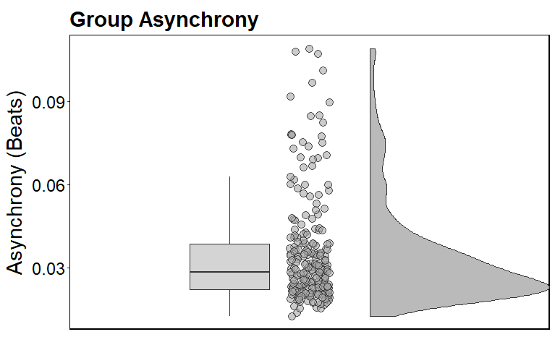

*Figure A.1 shows the distribution of asynchrony values in beats using a boxplot, individual data points, and a density curve. Most values cluster around low asynchronies (~0.03 beats), with a right-skewed distribution indicating a few larger timing deviations.*

**Figure A.2**

***Pair-Wise Asynchrony Values***

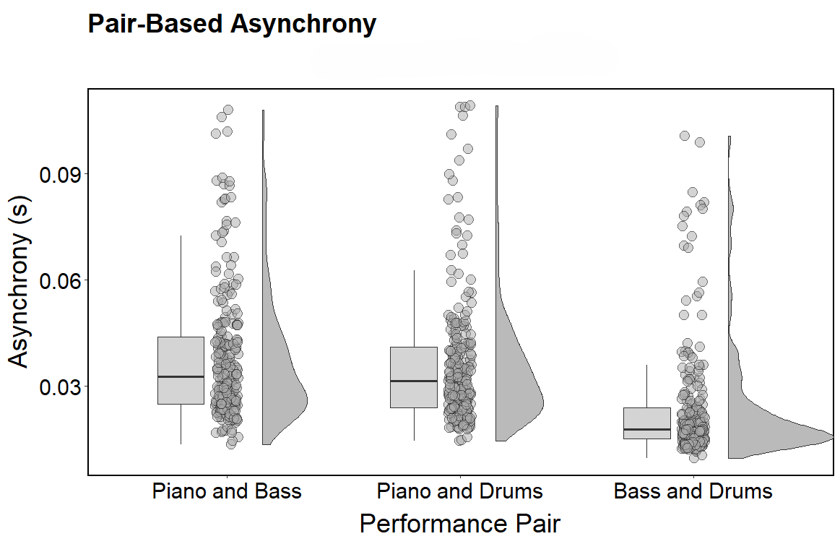

*Figure A.2 displays the distribution of asynchrony values in beats using a boxplot, individual data points, and a density curve for each unique combination of musicians. Again, most values cluster around low asynchronies (~0.03 beats), with a right-skewed distribution indicating a few larger timing deviations.*

**Figure A.3**

***Normalized Parameter Distributions***

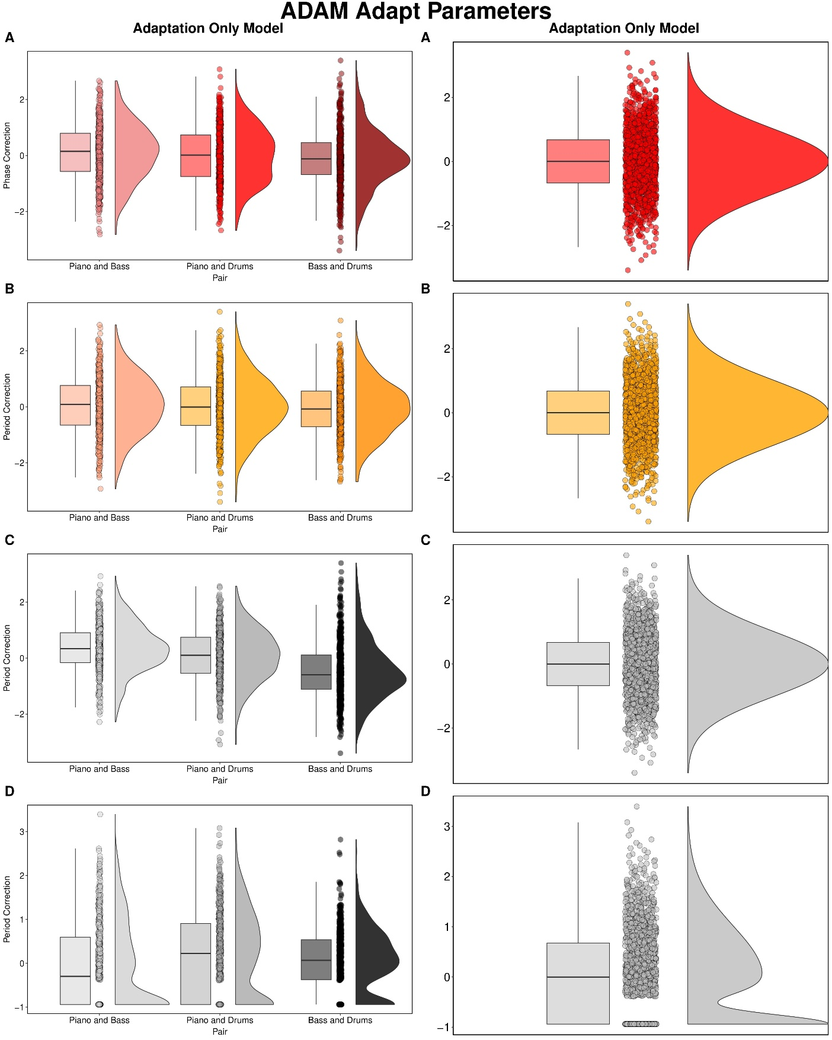

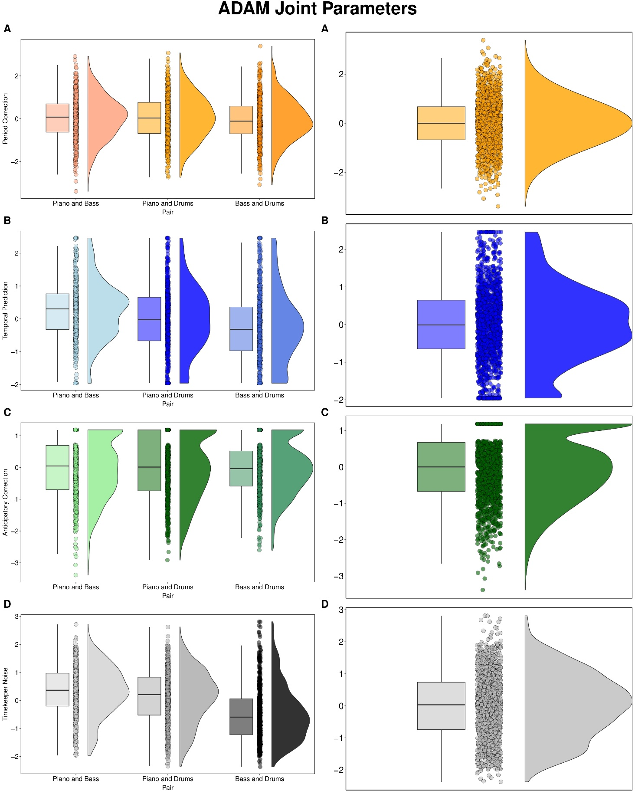

*Figure A.3 displays the parameter distributions for both the adaptation only and joint version of the ADAM after normalization using ordered quantile normalization at the group level as well as when split into unique pairings within the group. As shown, the normalization significantly improved the normality of the data within and across pairings.*

**Figure A.4**

***Interaction Plots for Parameter Predictions and Group Asynchrony using Fixed Effects***

|  |  |
| --- | --- |
|  |  |
|  |  |
|  |  |
|  | **Joint Timekeeper Noise Interaction Plots** |
| **Group Timekeeper Noise Interaction Plot** |  |

*Figure A.4 visualizes all of the complex interaction effects from group- and pair-level LMERs across the second and third research questions. Plots illustrate how synchrony and parameter values are shaped by tempo, complexity, and musical role, revealing the context-dependent use of adaptation and anticipation strategies. These visualizations helped to guide the interpretation of results for all three research questions.*